DEv Ops CI-CD

Mark O Donoghue

Tralee Institute Of Technology

Dev Ops

Table of Contents

Introduction 3

Chapter 1 Code and tools 4

1.1 Introduction 4

1.2 Flow Diagram 4

1.3 CouchDB 4

1.4 Java restful api 6

1.5 React Front end 7

1.6 Jenkins 9

1.7 Github 10

1.8 Slack 11

1.9 SonarCloud 12

1.10 Nexus3 sonatype 12

1.11 Docker 13

1.12 DockerHub 14

1.13 Ansible 15

1.14 Prometheus 16

1.15 Node_Exporter 17

1.16 Grafana 17

1.17 Maven 18

1.18 Selenium 19

1.19 Mockito, Junit & jaCoCo 20

Chapter 2 Continuous Integration 21

2.1 Setting up Ec2 instance 21

2.2 Installing jenkins on Ec2 instance 25

2.3 Github & GitHub webhook 31

2.4 Global Tool Configuration jenkins 34

2.4.1 Configuring Maven 34

2.4.2 Configuring Git 35

2.4.3 Configuring Extended Emails. 36

2.5 Unit Tests 38

2.6 Configuring SonarCloud 42

2.7 Nexus 48

2.8 Configuring Docker 53

2.8.1 Containerizing the 3-tiered webservice 55

2.8.2 Containerizing the CouchDb Instance 55

2.8.3 Containerizing the Restful Java API 57

2.8.4 Containerizing the React.js Front end 58

2.9 Production Environment 60

2.10 Setting Up Slack 60

2.11 Selinium Tests 61

Chapter 3 Building the Code and Configuring the pipeline 62

3.1 configuring a pipeline jenkins 63

3.2 Jenkinsfile 65

Chapter 4 End-to-end automation of the project’s configuration management and continuous delivery orchestration 74

4.1 Setting Up Ansible 74

4.2 Setting Up The Ansible Playbook 78

4.3 Full Process 83

Chapter 5 Monitoring Infrastructure & Application 96

5.1 Metric Gathering Tools 96

5.2 Prometheus 96

5.3 Node exporter 98

5.4 Grafana 99

Conclusion 100

References 102

# Introduction

The purpose of this paper is to demonstrate the CI-CD environment that was created to facilitate a 3-tiered application that was created last year. The application in question is an online book review web service. A number of tools were incorporated to facilitate this CI-CD environment. The tools that were used are.

* Github
* Slack
* Jenkins
* Junit
* Selinium
* SonarCloud
* Nexus
* Docker
* DockerHub (online registry)
* Ansible
* Java environment
* CouchDb environment
* Node.js environment
* Maven
* Junit, Mockito and JaCoCo

# Chapter 1 Code and tools

## 1.1 Introduction

This chapter will give a brief description of the application that was used for the purposes of demoing a ci-cd environment. The application is divided into 3 distinct areas that make use of their own individuals ports. When combined, they make up the single book review application. The 3 areas that were created are a CouchDB back end, A Java Restful API and a React.js Frontend. Also, this chapter will focus on the tools that were used.

## 1.2 Flow Diagram

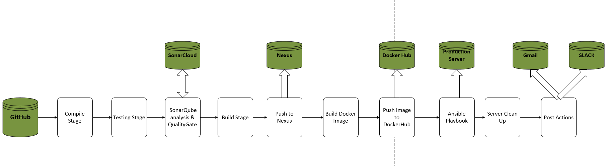

Figure 1 Flow Diagram of entire process

## 1.3 CouchDB

The application uses a No-Sql CouchDb backend to store review data as well as user data. The data store is document based meaning that all information for a given object can be stored in a single instance on the database and every object can be different to every other object. In this way, CouchDb does not need object relational mapping when storing data to its database. The data that is stored is in JSON format, meaning that the data is stored in key value pairs. For example, if you were storing information on a book it would look something like this in your database.

"_id": "6112fbf8c15ddd97375abe25740006df",

"_rev": "17-2d64fb1961431dd7de29ff30e0aa7f8d",

"title": "Majestic",

"description": "Depicts historical struggle of Spain and England",

"genre": "History",

CouchDB also makes use of a generated ID to uniquely identify, and also a revision number. CouchDb doesn’t delete the previous data when a document is updated, instead it tags a new document with a new revision number and the updated data is contained within. The revision number is essential for 2 reasons, a) to make sure that previous versions of the data can be accessed b) to ensure that the developer is working with the latest version of the data. An image of the CouchDB database that was used for the application can be seen below.

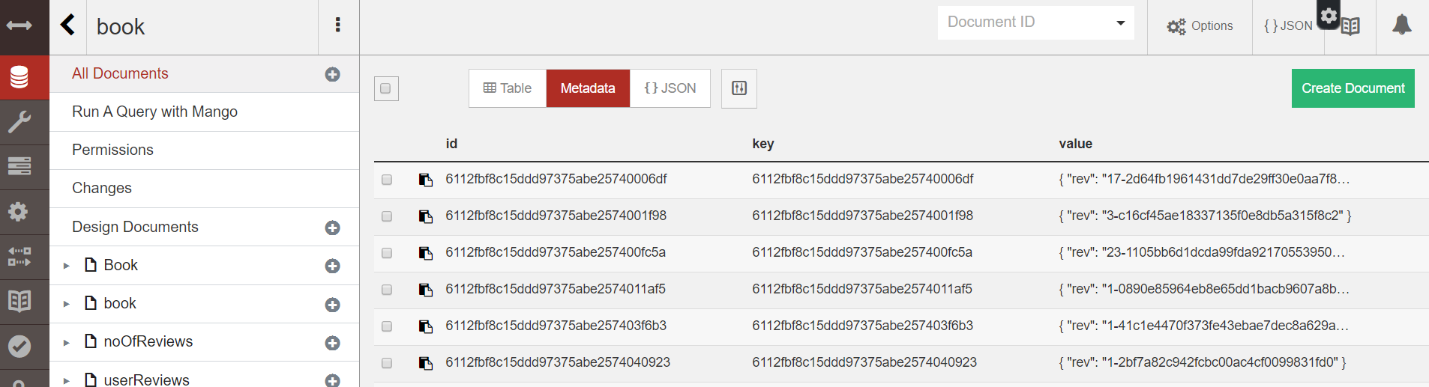

Figure 2 image showing contents of CouchDB database

## 1.4 Java restful api

A restful API was created to facilitate connections with the database and create endpoints that would serve up data to the Client. The Restful API was created using the Spring framework. The Spring framework was chosen for a variety of factors, chief among them was for the dependency Inversion that can be achieved through annotations such as @AutoWired and for the tiered approach to development that it provides (Controller, Service, Repository). As well as this, an Ektorp driver was incorporated into this layer in order to provide effective communication with the CouchDB database. The below image shows the structure of the RESTful Java Api.

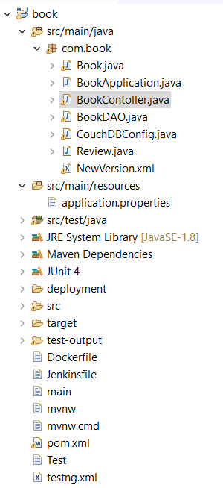

Figure 3 Shows the application structure of the Restful Java API

## 1.5 React Front end

Finally, a JavaScript library called React.js was used for the frontend of the application. React.js is owned and maintained by Facebook and using mechanism known as lifecycle hooks, in order to retrieve data and display to the client. React was used for a multitude of reasons most prominently being these lifecycle hooks and the ease of creation of a Single Page Application (SPA). Spa’s dynamically changes the view to the user when new data is available from the RESTful java API. In this way, the client facing application is reactive and views are updated by immediate changes in data as opposed to traditional methods like user input. The image below shows the react application displaying the data that is retrieved from the RESTful java API.

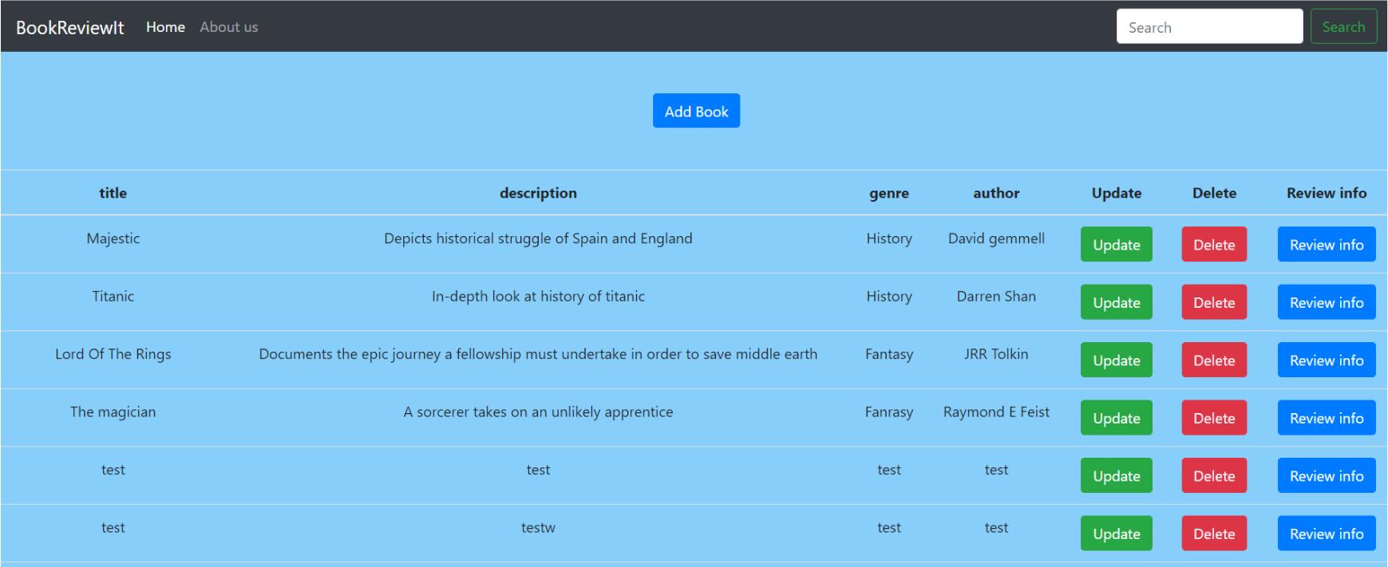

Figure 4 The view of the React application that was used

## 1.6 Jenkins

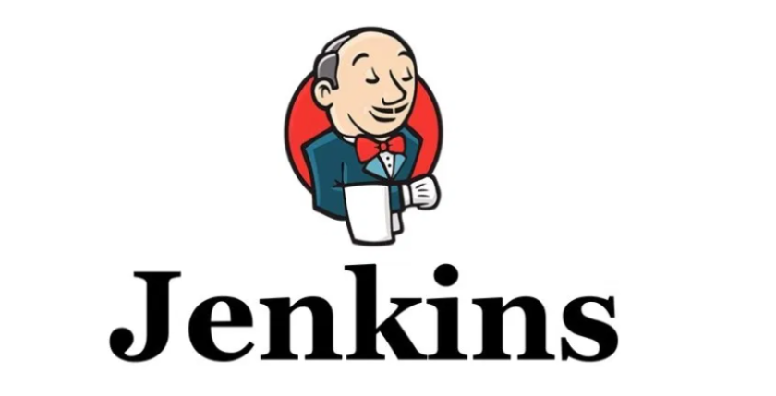

Figure 5 Jenkins logo

Jenkins is an open source automation server and is primarily used for facilitating the building, deployment and automating of a project. It is often referred to a CI-CD which is an accurate reflection of what Jenkins bring to the table. It is most often used with other tools in order to provide this environment, however fortunately Jenkins makes it easy to do this. Out of the box Jenkins doesn’t offer a lot in the way of plugins, tools etc. However, the software is totally customizable and offers 100’s of plugins to facilitate this integration with other tools. It can be as complex or as simple as the developer requires. For the purposes of my project, Jenkins was perhaps the main tool that was used to create this CI-CD environment, and this was accomplished through the use of a Jenkins pipeline. A Jenkins pipeline is a suite of Jenkins plugins that support integrating CI-CD pipelines into Jenkins. A CI-CD pipeline is an automated process for getting software from version control to the consumers(customers) of said software. The key ingredient to creating these pipelines is the creation of a special file called a Jenkinsfile. This file will detail the stages of your pipeline and can be edited by all members of the team. This file can be customized to provide a pipeline suited to your particular project and also serves as a “single source of truth for the Pipeline” (JenkinsOfficalDocumentation, 2020). This means that anyone familiar with a Jenkinsfile would be able to read it and have an immediate understanding of your projects CI-CD. The pipeline that was set up for my application will be explained a little later in the paper.

## 1.7 Github



Figure 6 Github logo

Github was used as the version control for the project. Its primary purpose is to manage and store all revisions of a project. How it works is you make your changes locally then you push these changes directly to the central repository. In this way, when a change is made every member of the team will have access to the latest version of the project. For the purposes of this project a git commit will be the catalysts that triggers the CI-CD of the project. This can be configured through the use of a git webhook and this will be explained in later in the paper.

## Slack



Figure 7 Image of the slack logo

Slack is a communication tool that was designed to facilitate seamless communication between a particular team. Through the use of channels, teammates can send messages and files. These channels can be configured to only allow access to certain team members so that information isn’t shared freely, but only with the relevant people. For the purposes of this project, a channel was created to inform relevant team members of the success or failure of the CI-CD process. In this way, team members would be informed quickly if adjustments are required to the code that they submitted to Git as the pipeline would have flagged an issue. Slack was used as the primary communication tool for the project along with email notifications to ensure that potential problems were flagged as soon they arose.

## SonarCloud

SonarCloud is a code analysis and vulnerability tool that is the cloud hosted version of the more well known SonarQube. It is an opensource tool and its primary purpose is ensuring that developers write cleaner and safer code. Aside from providing a detailed analysis of your code, it provides a detailed report on areas such as code coverage, vulnerabilities, technical debt etc. It can be configured to fail a build if the code pushed to your version control is not of a certain standard. In this way, the person who sets up the CI-CD environment can enforce a quality policy on the development team. This can be configured through the use of SonarClouds quality gate feature. In essence, a quality gate is a set of rules that the new code must adhere to in order to pass a build. A quality gate is fully customizable by the developer who created it and I will show the quality gate that I crated later in the paper. For the purposes of my project, SonarCloud was used to analysis the code as well as fail the build if the code being submitted wasn’t of a certain standard.

## Nexus3 sonatype



Figure 8 image of nexus logo

Nexus is classified as a repository manager. Its primary purpose is to collect and manage your dependencies/artifacts so that the developer isn’t left managing a large collect of war/jar files. Since at its core it is a repository manager, artifacts can be stored and numbered which correlates to different versions of your application. In this way developers can access different artifacts for the purpose of accessing different versions of their application. This can be incredibly handy if the application encounters problems as it can be then restored immediately to a previous working version.

## Docker

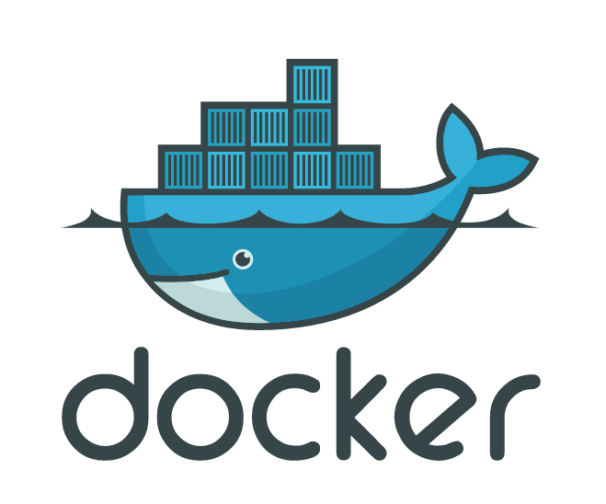

Figure 9 image of docker logo

Docker is an open-source tool that was designed to make a developer’s life easier by making it easier to create run and deploy applications. It accomplishes this goal through the use of containerization. Containers are essential to this process and a container is a way of packaging an application with all the dependencies, libraries dependencies and environment into a single instance. This instance is known as a container. This means that a developer can be assured that the application will run on another machine regardless of that machines customized settings. For the purposes of this project the 3 tiered web application will be containerized int 3 separate containers with 3 different environments.

## DockerHub

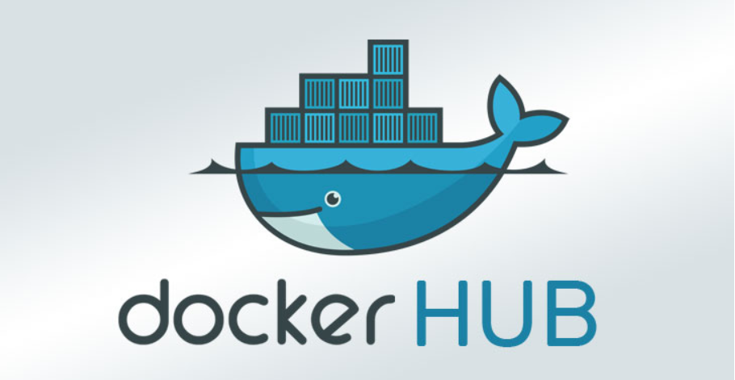

Dockerhub is a service that is provided by Docker and was designed to test, store and distribute a team’s container images. Dockerhub servers as a cloud host repository for a team’s containers and can be used to not only store all relevant containers but all versions of a container. In this way, it shares similarities with Guthub. For the purposes of my project, Dockerhub was used to manage all 3 containers that are used to create the 3-tiered webservice as well as manage all of the versions of each container.

## Ansible

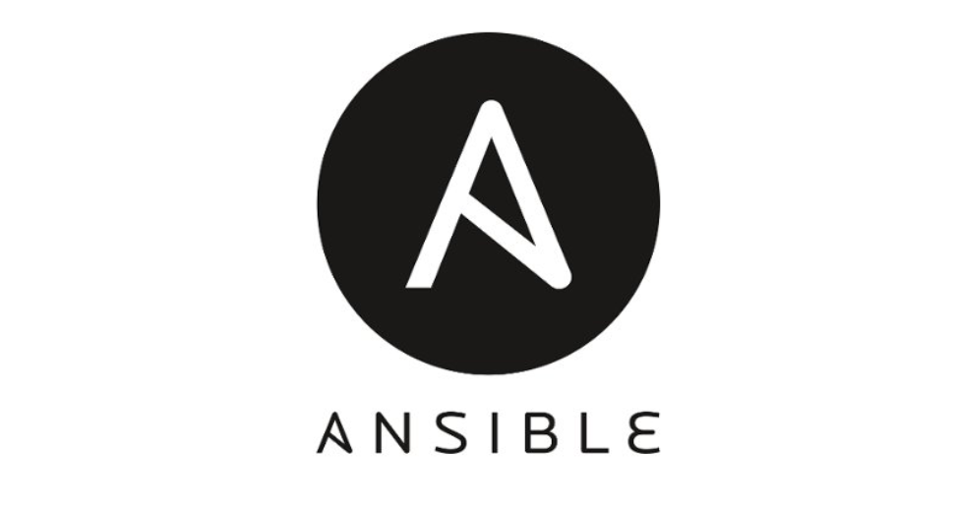

Figure 10 Ansible Logo

Ansible is an IT infrastructure automation system that enables centralized deployment, configuration, and application management. Its this automation that really highlights Ansible’s key strength is that any administration activity that can occur more than once can be fully automated. For my project Ansible was used primarily to configure environments as well as handle the continuous deployment of the project. It was also used as a recovery tool in that if my servers were to go down tomorrow the a simple commit to Git or running of the script would bring all environments back up and running this will be explained in detail later in the paper.

## Prometheus



Figure 11 Prometheus logo

Prometheus is open-source software primarily used for metric gathering, monitoring and alerting the developer to potential issues. Prometheus gathers data in the form of time series. They are referred to as time series because Prometheus queries a list of data sources at a specific polling frequency. It then stores the data in the form of metrics. Each metric will be given a unique name so that these metrics can be referenced and queried. Alerts can also be configured in Prometheus. They are configured so that if a certain condition isn’t met in relation to the metrics it is gathering, a notification will be triggered to a predefined user(admin). These notifications usually take the form of an email or a slack notification.

## Node_Exporter



Figure 12 Prometheus Node exporter

Node Exporter is another metric gathering tool that can be used in conjunction with Prometheus to offer additional metrics that you just wouldn’t have access to with just Prometheus. It allows for the measuring of various machine resources such as memory, disk and CPU utilization.

## Grafana



Figure 13 grafana logo

Grafana is open source software that is used for visualization and data analytics. What this means is that it can turn the data that is collected in Prometheus or any other datasource into graphs and visualizations. In essence, it provides a more easily interpretable representation of the data gathered by your metric gathering tools. Grafana also provides a whole host of other features that the user can make use of such as alerts, dashboard plugins, adhoc-querying, Authentication and much more. The main purpose of Grafana in my project was that of a visualization tool but I wanted to highlight the many benefits outside of this that the software provides.

## Maven



Figure 14 Maven logo

Maven is a build automation tool that is owned and maintained by Apache and is primarily used for java projects. It has two primary focuses, these being the build of a project and managing a project’s dependencies. It makes use of a Project Object Model (POM).xml file. This pom file describes how the project is built, what dependencies the project needs access to and what plugins to configure. It also makes use of building lifecycle commands that will be essential to the Jenkins pipeline that will be configured later. These lifecycle commands accomplish a lot and can be used to compile, test and package your application into a war/jar as well as much more. How this tool was implemented into Jenkins will be explained later in the paper.

## Selenium

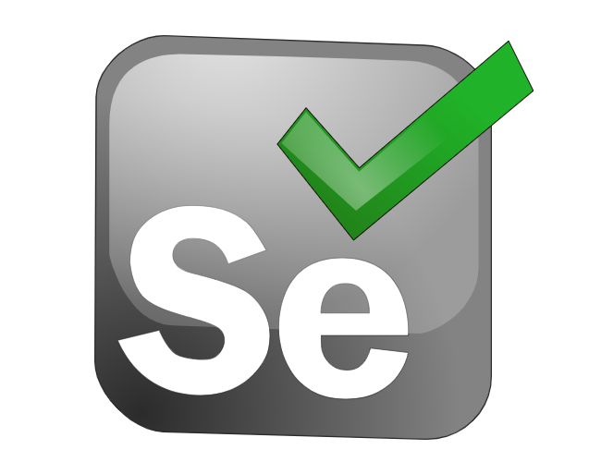

Figure 15 Selenium Logo

Selenium is open source automated testing framework that is designed specifically for testing web applications via a browser. In essence, it is a UI automated Testing software. The tests that are ran can run against virtually all browsers and the software was designed to work on a vast amount of Os’s. Selenium incorporates a suite of software that can be seen listed below.

* Selenium IDE
* Selenium client API
* Selenium WebDriver
* Selenium Grid
* Selenium Remote Control

## Mockito, Junit & jaCoCo



Figure 16 mockito logo



Figure 17 JUnit logo



Figure 18 JaCoCo logo

Finally, as my code testing tools, I used Mockito, Junit and JaCoCo. Mockito is a mocking framework that is used for mocking interfaces and services. Junit is a unit testing module that is used for java. JaCoCo is a code coverage tool that provides detailed reports on how much code has been covered.

# Chapter 2 Continuous Integration

This chapter will focus on how what tools were used to facilitate to CI-CD and how they were configured. The goal wasn’t just to create this environment but the automate the entire process from a single Git Commit. The Headers below will outline the stages needed to create this environment. I picked AWS as my cloud provider after running into monetary issues with OpenShift I created the majority of the CI-CD environment on that platform also but because of these monetary issues had to switch to AWS.

## Setting up Ec2 instance

In order to set up an Ec2 Instance, the first step is to create an account with them. After creating the account, you will have access to the management dashboard. From here just click on launch instance as seen in the image below.

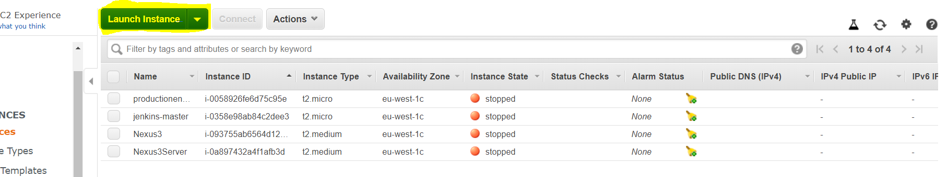

Figure 19 creating an Ec2 instance to

After this, choose the next step is to choose an appropriate Amazon machine image (AMI). The AMI that I picked can be seen in the image below.

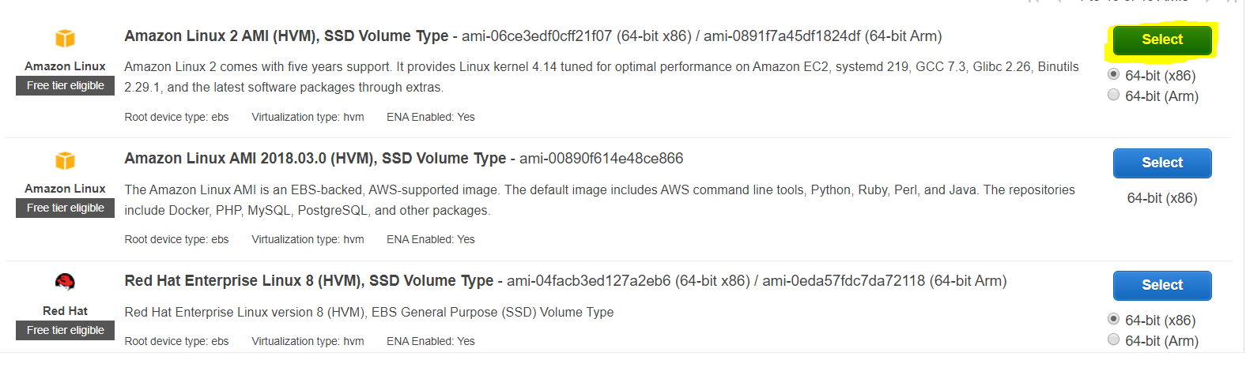

Figure 20 AMI that was selected for my Ec2 instance

Next I selected the size of the ec2 instance for my Jenkins server I went with a t2.micro . I was trying to keep monetary costs to a minimum selecting a server of this size.

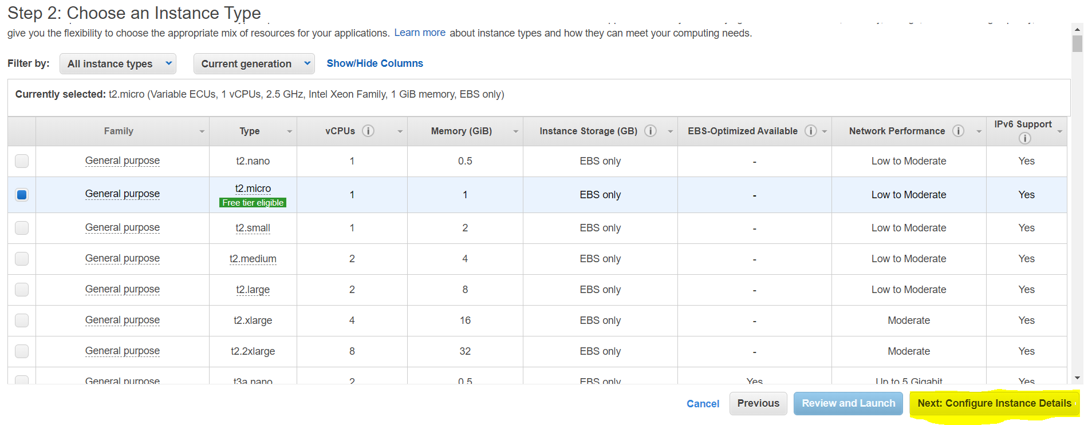

Figure 21 Selecting the size of the Ec2 instance

After selecting the instance size, the next step is to configure the instance. For this, I created a private subnet and enabled auto assign public IP. This is vital so that I can have an IP address to connect to my ec2 instance. Following this, I went to the add storage section.

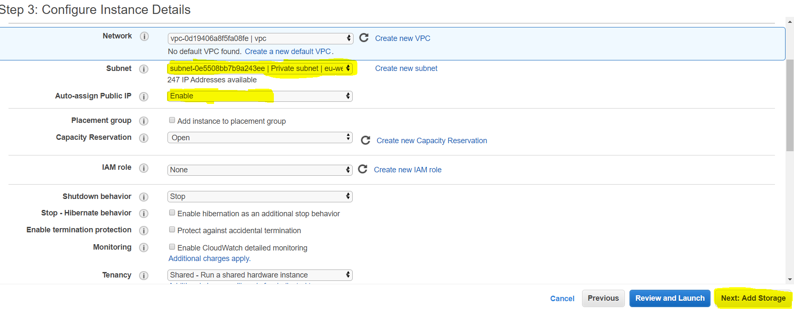

Figure 22 configuring the instance

I just skipped through this section as can be seen below.

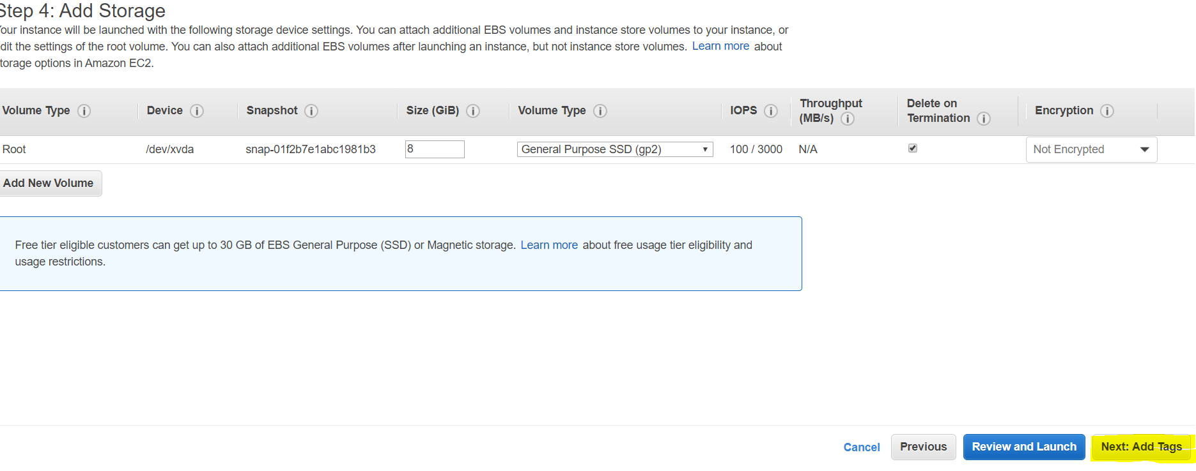

Figure 23 add storage section ec2 instance

In the tag section, I added a manually added a tag. The tag I added was a Name tag, this gives a name to my ec2 instance so that I can distinguish it from other instances. As can be seen below is jenkins-master

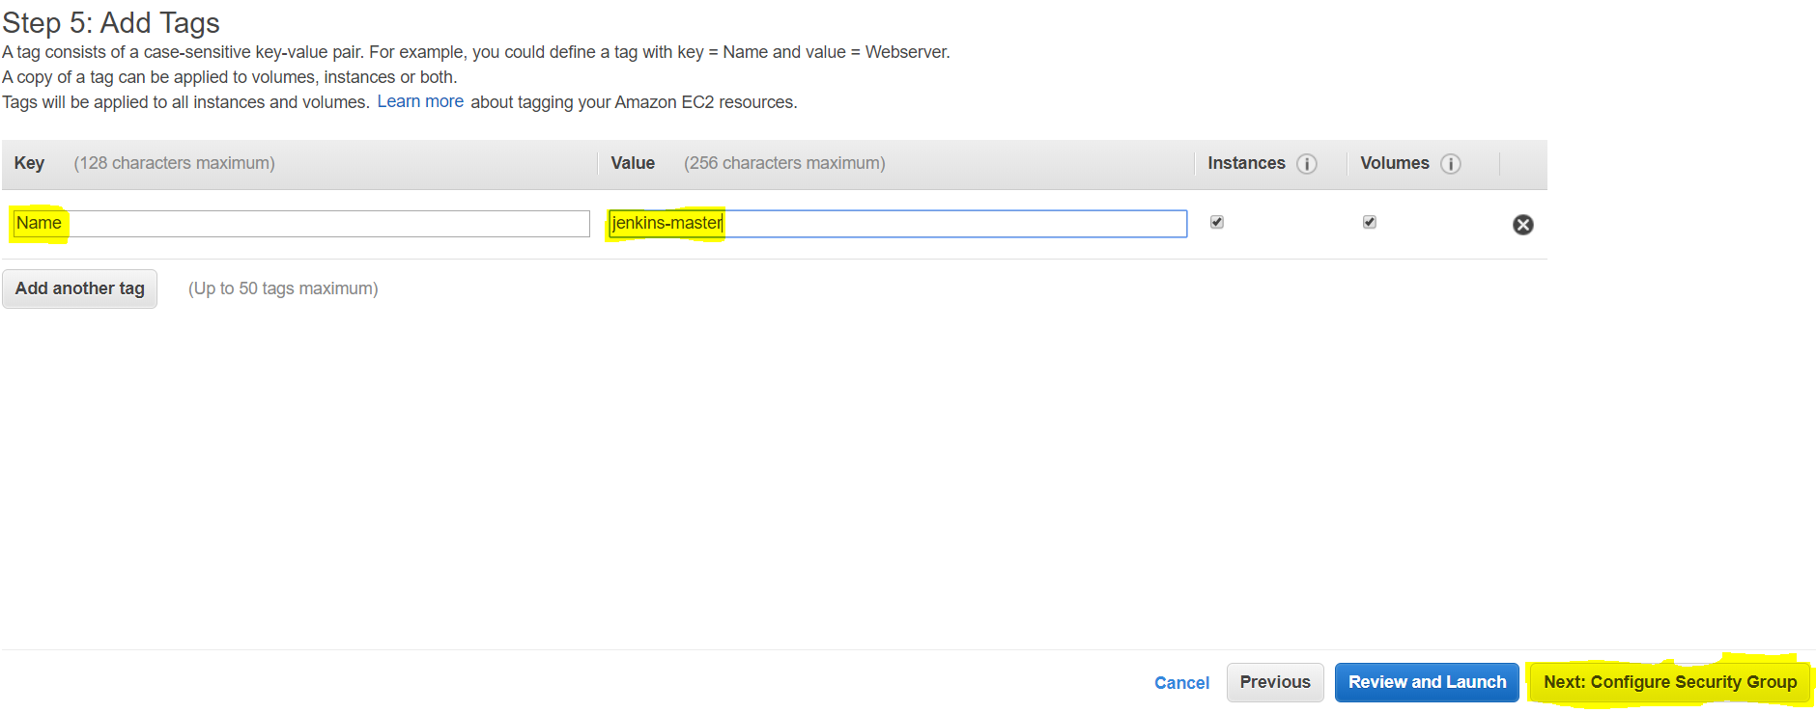

Figure 24 adding a name tag to the ec2 instance

The next step is vital in making sure that other processes/instances can interact with this ec2 instance. I configured a security group prior to this called wideopen2. I configured this group to allow all traffic to connect with it if this isn’t done it will not allow connections from outside your instance. I’ve highlighted the group in yellow.

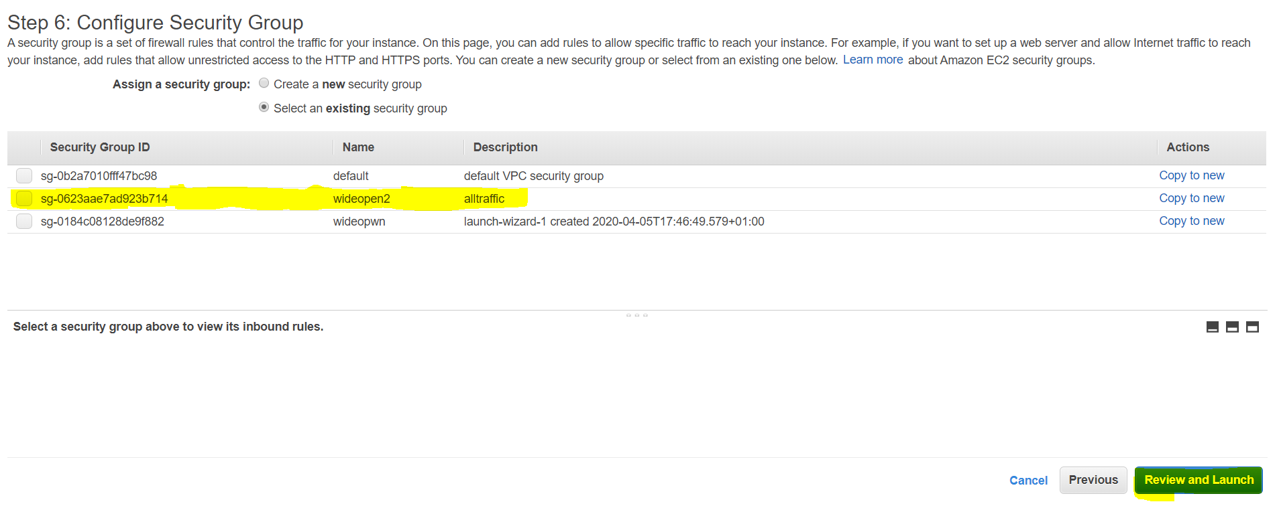

Figure 25 configuring the security group

After this you can review the settings you selected and launch the instance. After the instance has finished configuring and performed its security checks, it should look like the image below. At this stage, an ec2 instance has been created and your now able to add Jenkins to this ec2 instance.

## Installing jenkins on Ec2 instance

After creating the ec2 instance the next step is to the is to SSH into the instance. In order to do this, I had to create a private key using PuttyGen. The private key that I generated was called “Markskeypair”. The next step is to get your connection details from AWS . The connection details consist of a string that contains the default user that AWS creates when creating an instance and the IP address of the ec2 instance. The image below shows the details being entered.

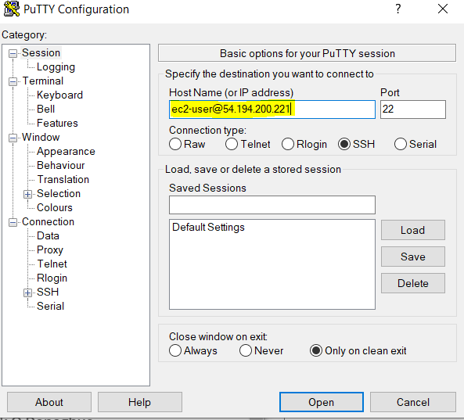

Figure 26 Connection details

The next step is to is to load in the private key pair that was generated in PuttyGen. To do this click the connection section, then the SSH section,then the Auth section. Now upload your private key in the user input provided. The information that I provided can be seen below.

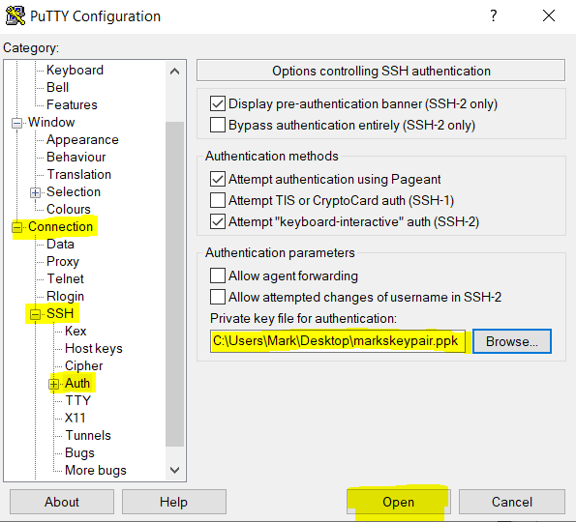

Figure 27 the details that were used to connect to ec2 instance

After doing this and selecting the open. The ec2 instance terminal opened meaning that the connection was established.

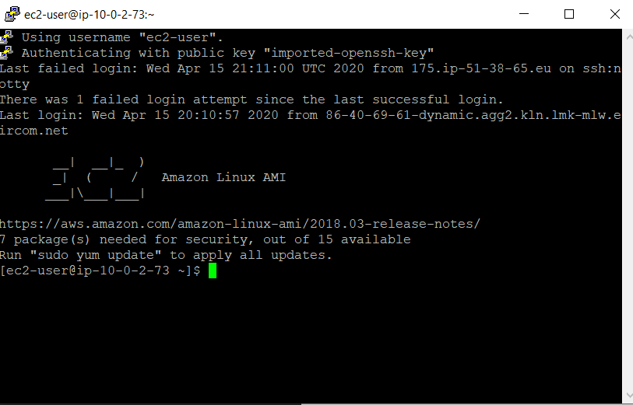

Figure 28 Connection established to ec2 instance

The first step was to update the ec2 instance to ensure that all installed packages had the latest packages. To do this, either become a root user or just use the “sudo yum update -y” command.

The next step was to configure the Jenkins environment. Jenkins requires a java version of 1.8 or higher. The ec2 instance came preloaded with java 1.7. To install java 1.8 use the command “sudo yum install java-1.8.0”. After issuing the command you can use the “java -version” command to ensure that it has successfully installed. The image below shows this command being executed on the terminal.

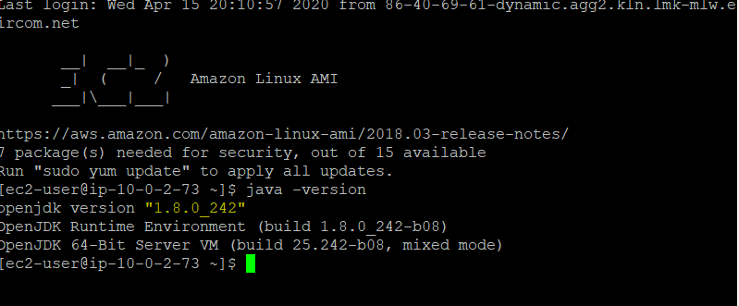

Figure 29 java version on ec2 instance

After configuring Java, the next step was to install Jenkins. Three separate commands were issued, and they can be seen in the images below

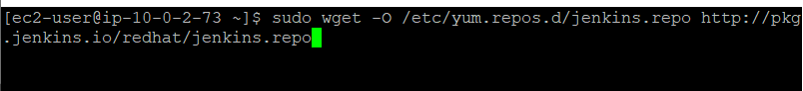

Figure 30 command used to install Jenkins on ec2 instance



Figure 31 2nd command used to install Jenkins



Figure 32 3rd command used to install Jenkins

After installing Jenkins, the next step is start Jenkins as a service the image below shows how this is done.

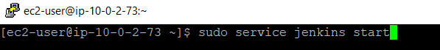

Figure 33 starting Jenkins as a service

After issuing the above command, Jenkins can be accessed by the user via the public IP address and the port number that it is listening on. The public IP address will change every time the ec2 instance is stopped and started. The image below shows me accessing Jenkins on the public IP that the ec2 instance was given at that particular time.

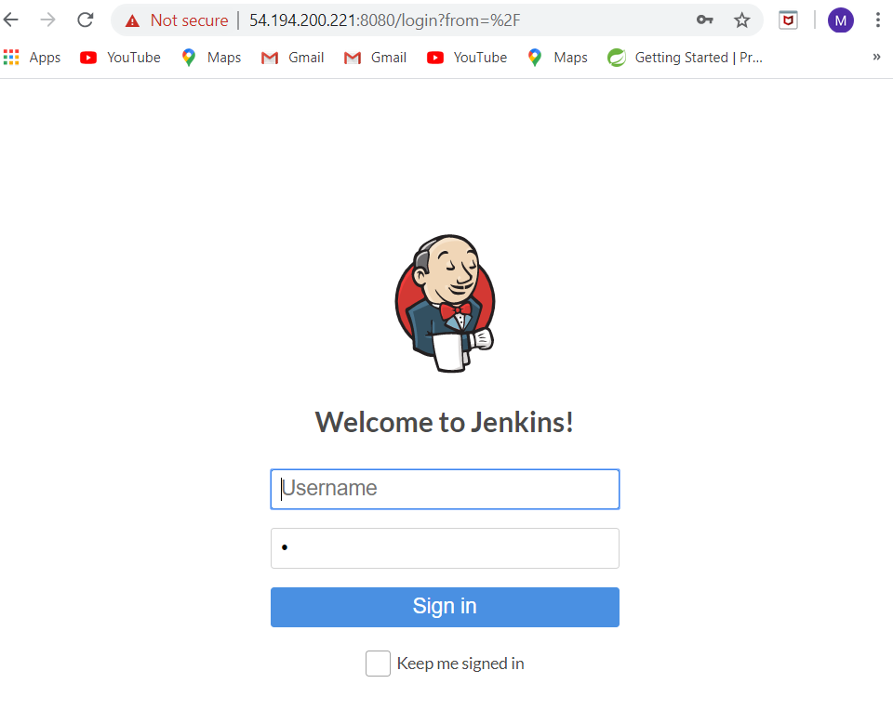

Figure 34 jenkins welcome screen

After entering in a new username and password, the user will be able access Jenkins fully and will be brought to the following screen.

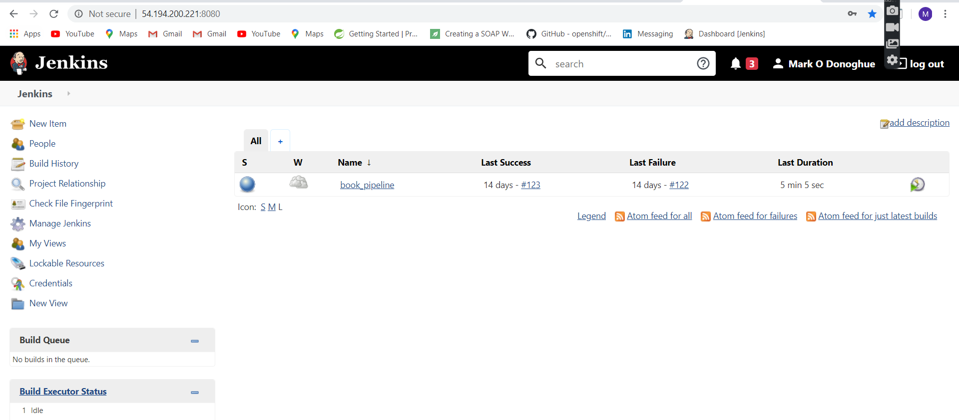

Figure 35 jenkins screen after entering successful details.

At this stage, Jenkins has been successfully configured the next step is to to configure version control and use a Github webhook to trigger my Jenkins pipeline.

## Github & GitHub webhook

First step was to create a repository called DevOpsOpenShift. This repository will then house the application that I discussed in chapter 1.

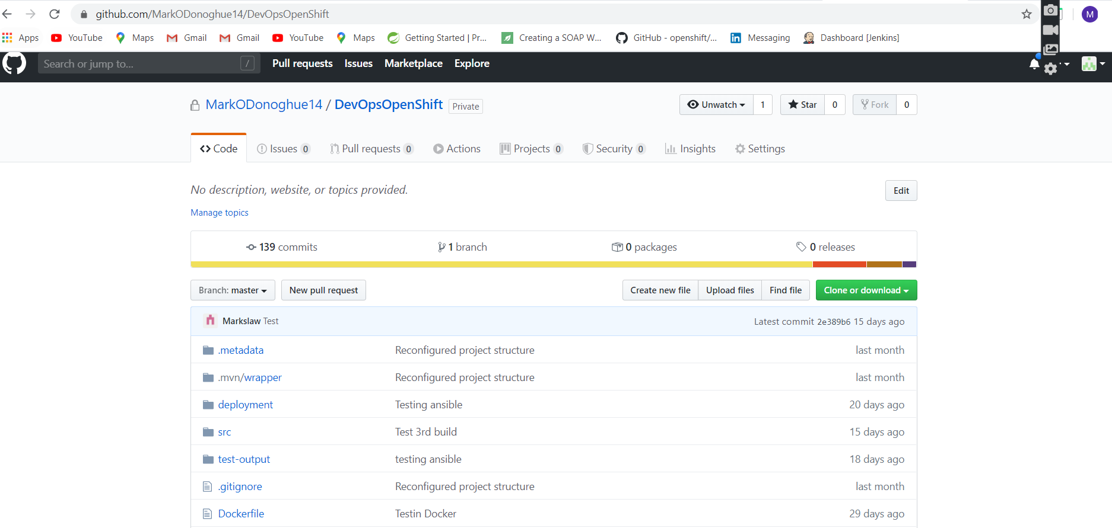

Figure 36 Repo that was created to house application

After creating the repository, the next step was to create the Github webhook. This is needed so that when a developer makes a commit to the above repository, the pipeline process will start. For my webhook I specified that address of my Jenkins URL as well as the key word that define it as a webhook “github-webhook”. In this way, you are subscribing Jenkins to the repository and any changes will alert Jenkins. I also specified the content type as application/json as can be seen below. This just means that the communication mechanism will use a JSON payload. How this was accomplished can be seen in the images below.

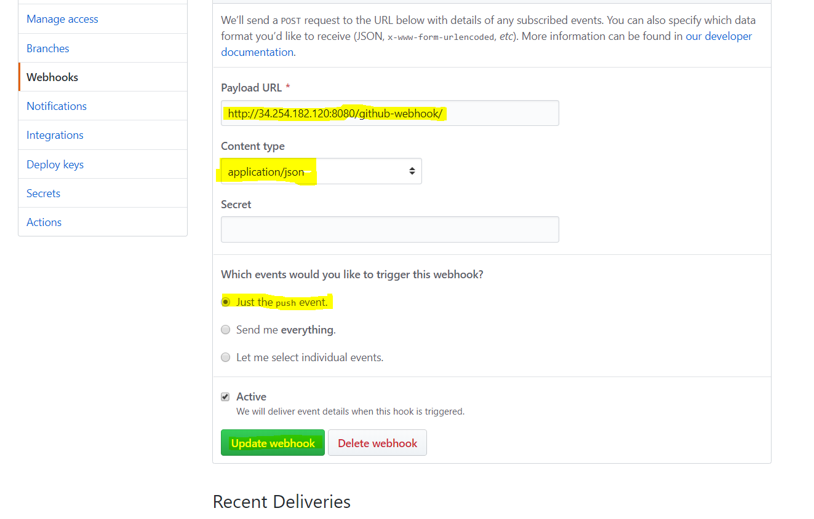

Figure 37 Configuration details of Github webhook

Since this webhook was created a few days before this paper I can show the recent deliveries of the payloads. This ensures that Jenkins and Github have been communicating. This can be seen in the image below.

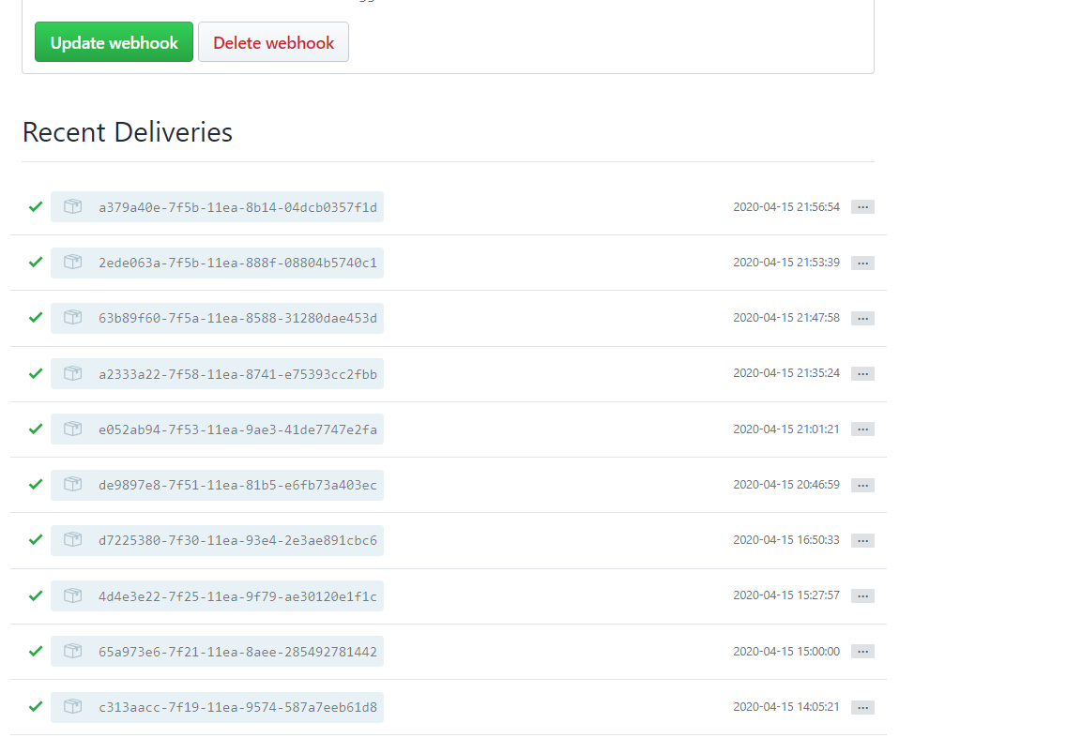

Figure 38 Json packages being delivered github

Following setting up the Github webhook, the next step was global tool configuration in Jenkins.

## Global Tool Configuration jenkins

The next step was to create and install the global tools that Jenkins will need access to such as Maven and emails etc. We shall first look at how to configure our build tool Maven

### Configuring Maven

The build tool that I went for in the project is called Maven. The application that I created for this project already makes use of Maven in the form of a Project Object Model (POM)xml file. So, installing Maven on Jenkins is crucial. In order to install it you will need to acquire the Maven plugin, then just navigate to Manage Jenkins and then Global Tool Configuration. Once on this page, just navigate to the Maven section and select the version of Maven that you would like to use and give it a name. This step can be seen in the image below.

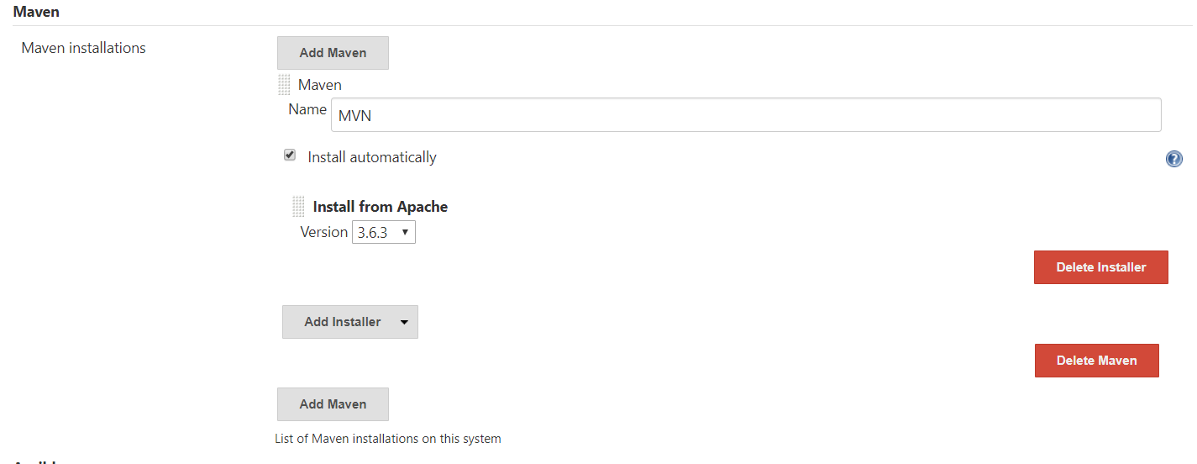

Figure 39 The configuration of Maven I provided for my Jenkins instance.

The version I selected is 3.6.3 and once this step is completed you have successfully configured Maven on Jenkins.

### Configuring Git

The next step that I undertook was configuring the Git on the Jenkins server. To do this, I just opened up my Jenkins instance terminal and used the below command to install it.

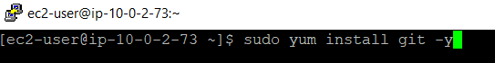

Figure 40 Command used to install Git

The above command will install Git onto the Jenkins server. It will get all the packages and dependencies that are required. After executing the command, Git is successfully installed on the Jenkins server.

### Configuring Extended Emails.

After Configuring Git I configured extended emails by downloading the relevant plugin then navigating to the configure system page in Jenkins. After navigating to here, look for the Extended email section. Then I entered the relevant details to allow for email communication. The details I entered can be seen in the image below.

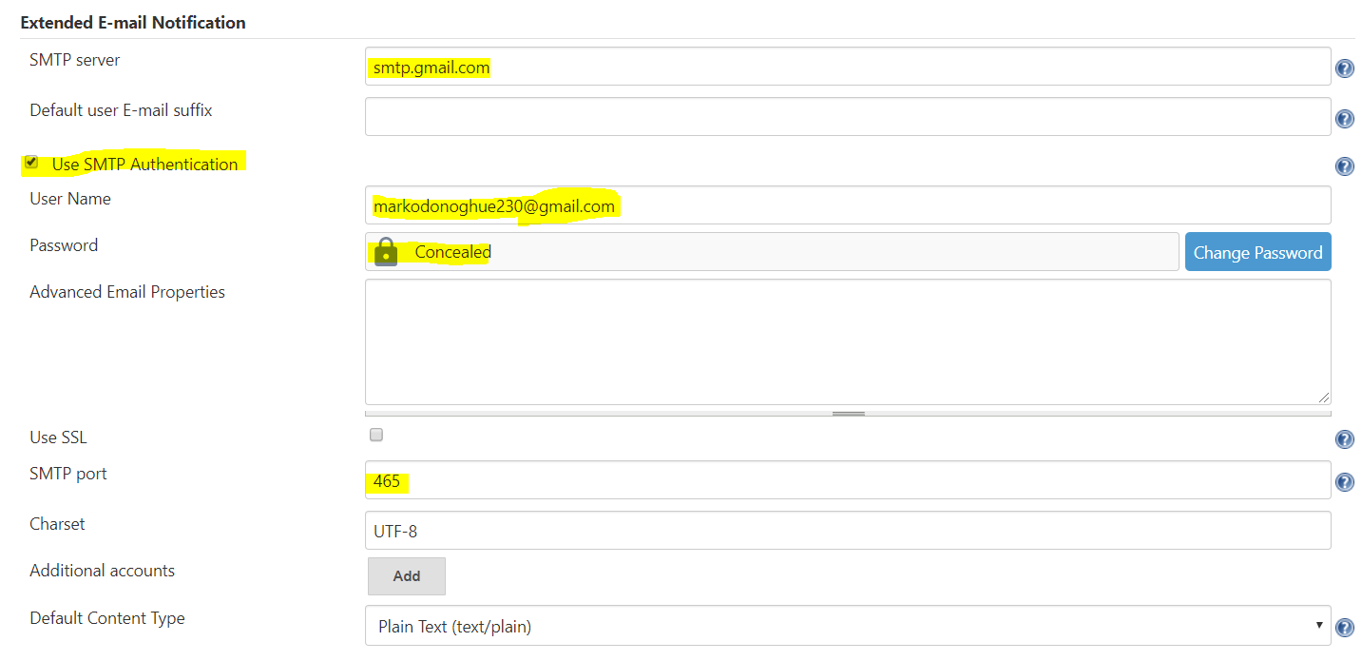

Figure 41 configuring emails.

In theory, this is all that’s needed to send emails. However, because of how gmails security is configured, additional configuration is required. In order to get around gmails security restrictions, you need to allow for access from less secure apps. The image below shows this.

.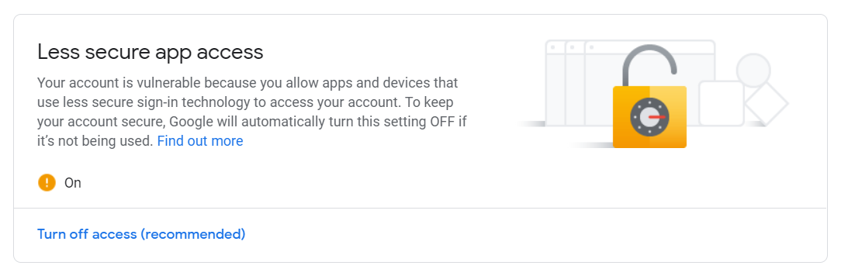

Figure 42 allowing access from less secure apps gmail

You also need to also need to bypass gmails unlockcaptha security and a simple googhle search of unlock captcha gmail will take you to the below link were you need to hit the continue button.

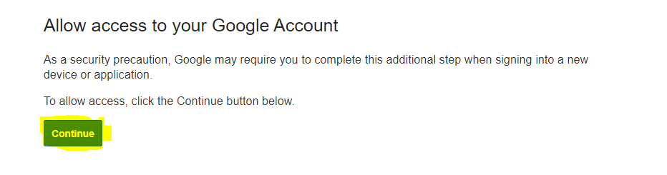

Figure 43 Unlock Captha Form gmail

At this stage, you have bypassed gmails security restrictions and are ready to send emails. Since I have already created this environment a while ago, my Jenkinsfile already specifies to send emails if a build is successful or unsuccessful. The image below shows a successful build email from Jenkins to my own email.

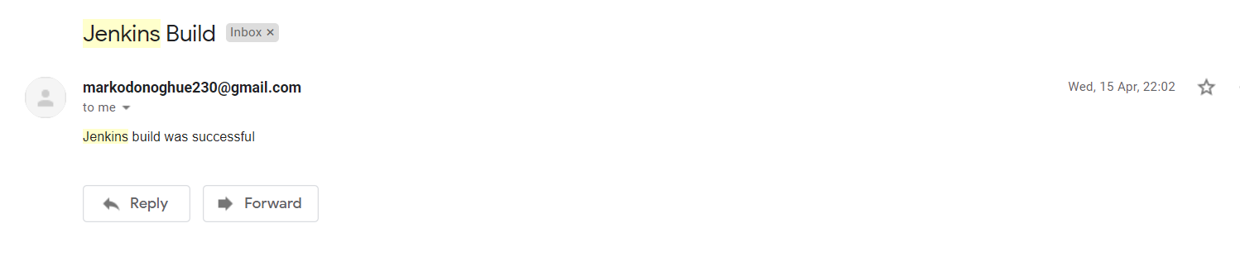

Figure 44 message from Jenkins to my personal email

## Unit Tests

The next step I took was to write unit tests for my Restful Java API. The application didn’t have unit tests prior to this, and I used Mockito as my testing tool in this instance. The image below shows the unit tests that were added to the application. These were unit tests that were performed on the applications controller.

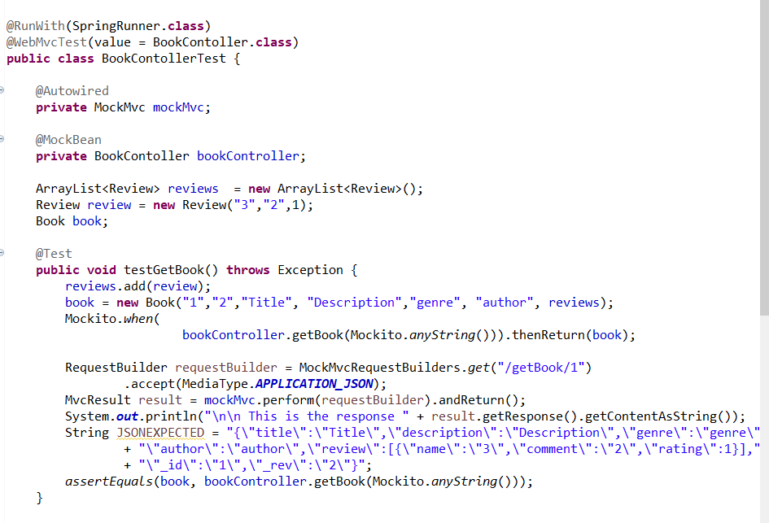

Figure 45 Unit tests part 1

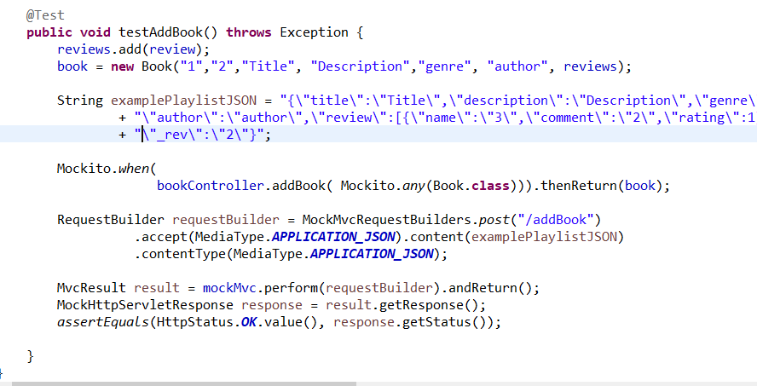

Figure 46 Unit tests part 2

After adding the unit tests, I added the Mockito dependency that was needed to execute them to my pom.xml file. This dependency can be seen in the image below.

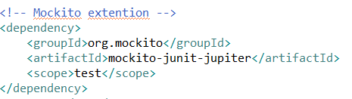

Figure 47 Mockito dependency that was added

I then issued the command test or in my Jenkins file “MVN test” in order to run them. The output from the console log looks as follows and shows that the tests have successfully executed.

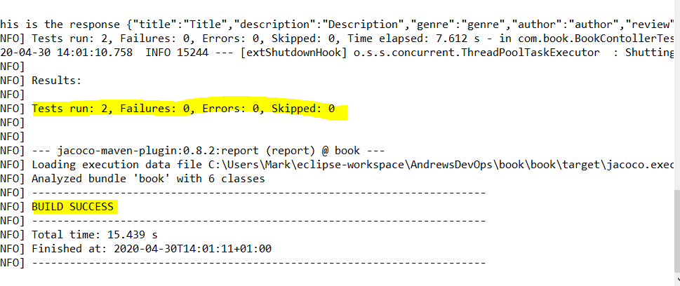

Figure 48 shows the build was successful and the tests executed

After ensuring that my unit tests were working correctly, the next step was to use a dependency known as JaCoCo in order to display the amount of code coverage that these unit tests were providing. This step is essential as SonarCloud will not know the code coverage without this. This would have hampered the plans that I had for the Quality Gate that I eventually configured on it. In order to get access to the JaCoCo library, I added the following dependency in my pom.xml file.

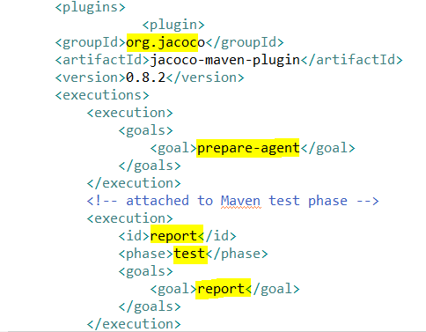

Figure 49 JaCoCo plugin plus goals that are executed

After installing every dependency or changing the pom file at all, a maven update is required so we will assume from this point onwards that I execute that goal each and every time I alter my pom.xml file. After the application has been updated, you can access the code coverage through “index.html” file. The image below shows the code coverage report from JaCoCo.

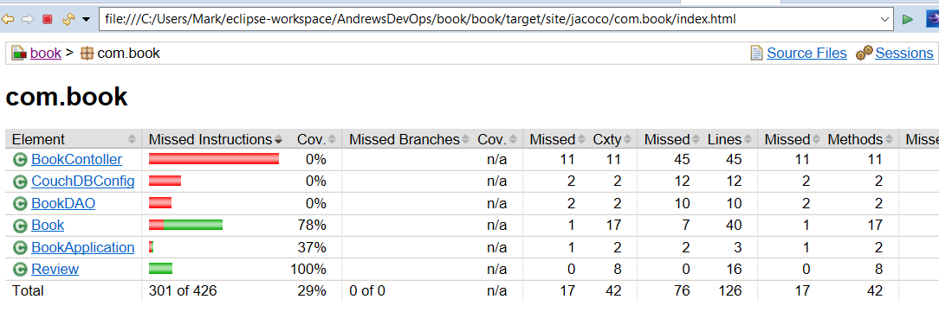

Figure 50 image from the JaCoCo code coverage report

This report is vital to the success of SonarCloud as it is this report that SonarCloud will read then display the code coverage to the user.

## Configuring SonarCloud

Now that the unit tests and jaCoCo are working correctly the next step is to configure SonarCloud. SonarCloud is the cloud hosted version of SonarQube and can be accessed from the following URL “sonarcloud.io”. The first step in configuring SonarCloud was to login using my Github credentials. Once you have logged into SonarCloud you will see a screen like the one below.

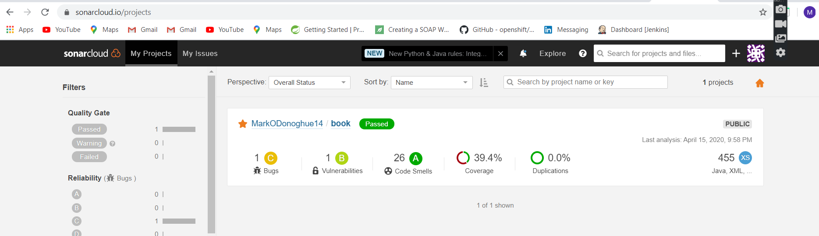

Figure 51 image of sonarcloud after login

The next step was to specify the build tool of the project in order to get access to dependencies needed to integrate SonarCloud into your project. The dependencies that were added to my pom.xml file can be seen dependencies that below.

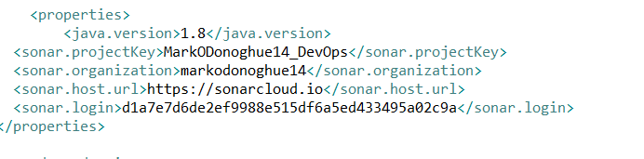

Figure 52 dependencies that were added to the pom.xml file

Once this dependency has been configured, we can test it locally using the “sonar:sonar”command or the “MVN sonar:sonar” command in the Jenkinsfile.

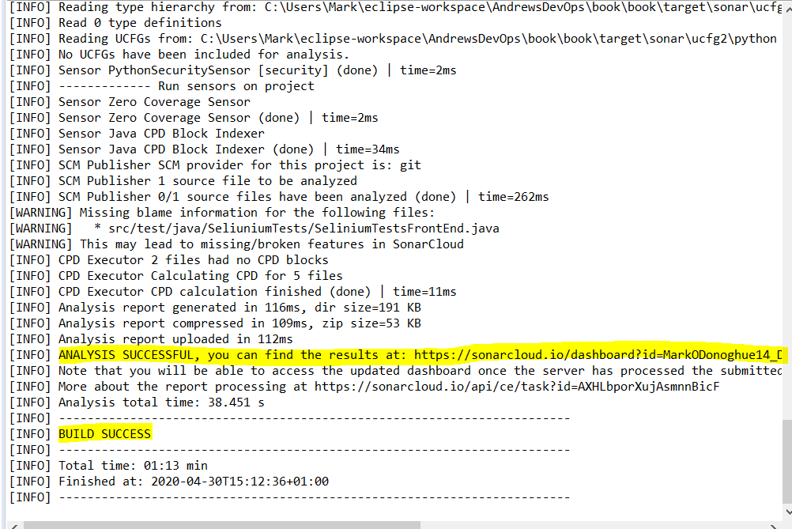

Figure 53 console output from the execution of the sonar:sonar command

The image above shows that the analysis was successful, and the image below shows that SonarCloud has picked up the jaCoCo report and performed its own analysis of the applications code.

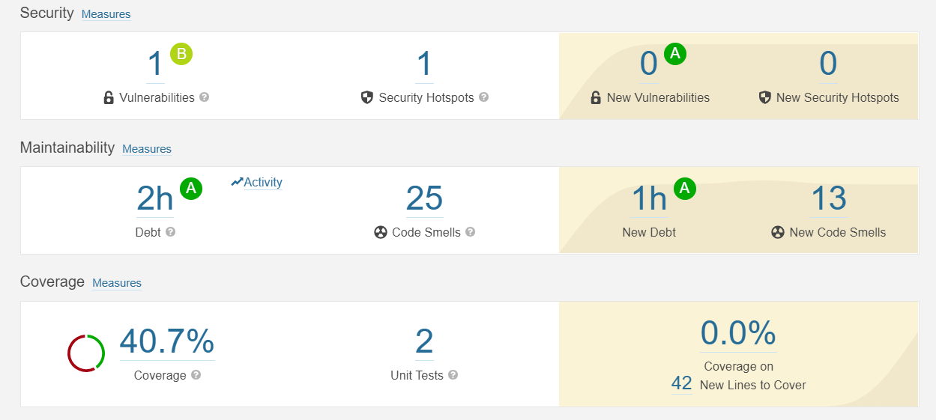

Figure 54 some of the metrics that were gathered on the application

As per the video, I submitted this process kicks off every time I commit to Git. In the video, I demonstrate how the quality gate works. Here, I will show how I configured the quality gate. Out of the box SonarCloud comes configured with its own default Quality gate called “sonar way”. I added another quality gate that I called Code Coverage. I then added 4 conditions using the add condition button. The conditions I added were to do with.

* Code Coverage
* Duplicated Lines
* Security Rating
* Skipped Unit Tests

The image below shows the conditions that were added to the quality gate that I created.

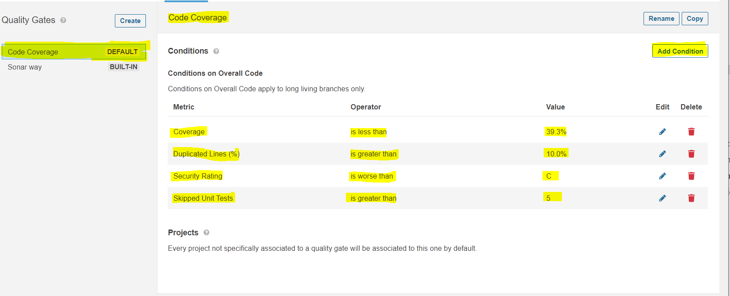

Figure 55 Quality Gate that was configured in SonarCloud

If the above conditions are not met, the quality gate will fail. As I already demonstrated in the video, this is integrated into my pipeline and I have demonstrated how the quality gate passes and fails in that video.

Finally, to facilitate communication with my Jenkins server and SonarCloud a webhook needs to be created. The webhook will pass a JSON Payload to the Jenkins server letting it know the status of the quality gate. In my opinion, the quality gate is of vital importance as when configured correctly into the Jenkins pipeline it will abort the build if the code isn’t of a certain standard. To configure the webhook, you need to navigate through administration then the webhooks button. Then you need to click the create button that will then take you to the following screen.

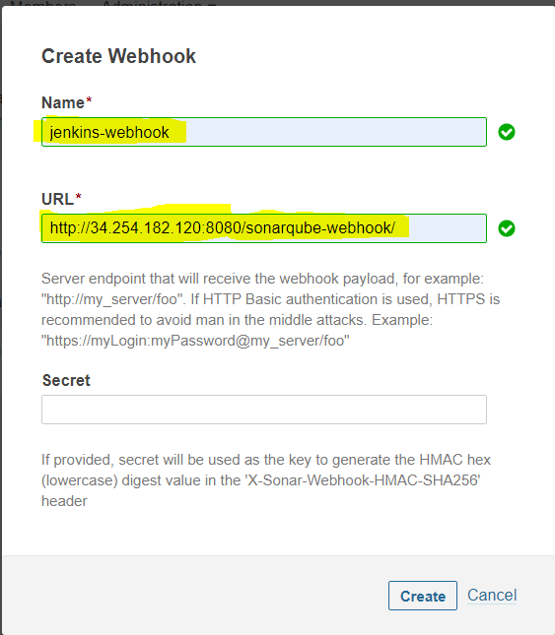

Figure 56 Shows how to configure the webhook

As can be seen in the above image, I created a webhook with the name “jenkins-webhook”. In the URL section, I specified the public Ip address of my Jenkins server and the port that it is listening on. To signify that this is indeed a webhook “/sonarqube-webhook/” must be added to the URL without this the webhook will not work. Once the details above have been entered, hit the create button. Since my pipeline was already created and builds have been running on it already, we can see in the image below that SonarCloud JSON payloads are reaching the Jenkins server as shown by the green tick next to it.

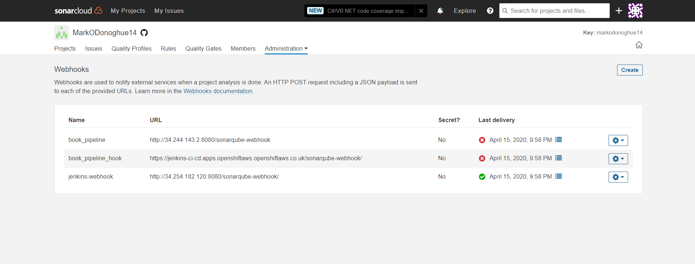

Figure 57 webhook working

Finally, it is important to note that none of this will work if the Jenkins server hasn’t a valid SSL certificate. When I was doing this on OpenShift originally, I was unable to configure this webhook, as SonarCloud removed the feature to allow this in an update a number of years ago. I didn’t have this issue on AWS instance at all, but I feel it is important to highlight and official message about the this can be seen in the image below.

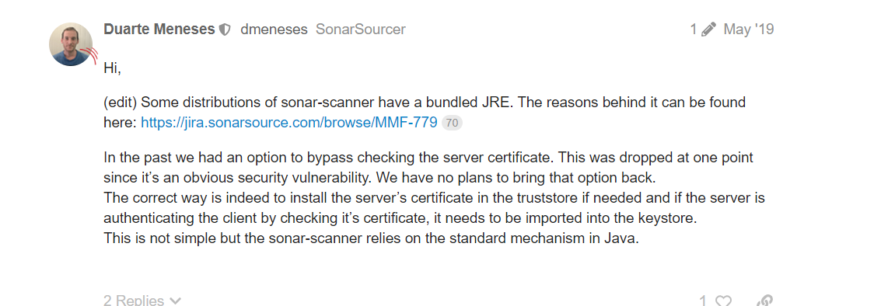

Figure 58 Message from a developer at SonarSource.

After configuring SonarCloud the next step was to configure Nexus.

## Nexus

In order to configure Nexus, the next step was another AWS instance had to be created. Unfortunately, nexus requires a minimum of two CPU’s so when I was configuring the instance, I had to use a medium tier as opposed to the micro tier I Used for the Jenkins server. The details of how I created the instance and ssh’ed into it can be seen under heading 2.1

After connecting the new Aws instance, the first step to creating my Nexus environment was to download the needed Nexus dependencies. The command in the image below was used to accomplish this

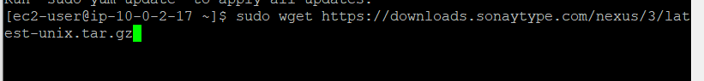

Figure 59 Nexus download

The next step was to extract the files. After extracting the files, you should have a directory structure like the one shown below.



Figure 60 Directory structure of extracted files

After extracting the files, the owner of each file is now root user. The next step is to change ownership of two of these files to the ec2-user. The command shown in the image below was used to do this.



Figure 61 command used to change ownership

The image below confirms that the ownership has been changed

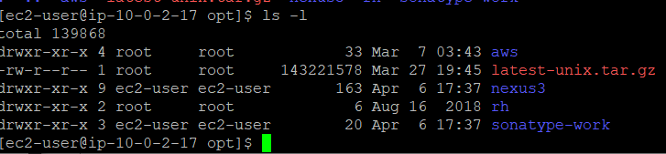

Figure 62 files that were extracted plus ownership info of the files

The next step was to install java on the ec2 instance, something that I have already explained how to do. Nexus needs access to the JDK in order to work.

After installing Java, the next step is to modify nexus so that it is runnable by the ec2 user. To accomplish this step, a file called nexus.rc had to be altered to include user information. The contents of that file can be seen below.

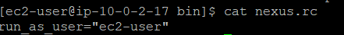

Figure 63 contents the nexus.rc file

The next step was to configure nexus as a service. In order to accomplish this, a soft link had to be created in the /etc/init.d location. The image below shows the command that was used to accomplish this goal.



Figure 64 The command that was used to create a soft link

The next step was to add the nexus to the chkconfig. The command below was used to accomplish this.



Figure 65 adding nexus to chkconfig file

The next step was to use the following command



Figure 66 allowing nexus to start on reboot

This was done so that nexus can be automatically started on reboot. This means that nexus will be launched each time the ec2 instance is started after being stopped with no manual intervention.

The final step to launching nexus is to start the service. This can be done using the following command.



Figure 67 command used to start nexus

After Nexus has been started you can view it at the ec2 instances public IPaddress on port 8081. An image of the nexus server that was set up and was accessed through the instances public IP address can be seen below.

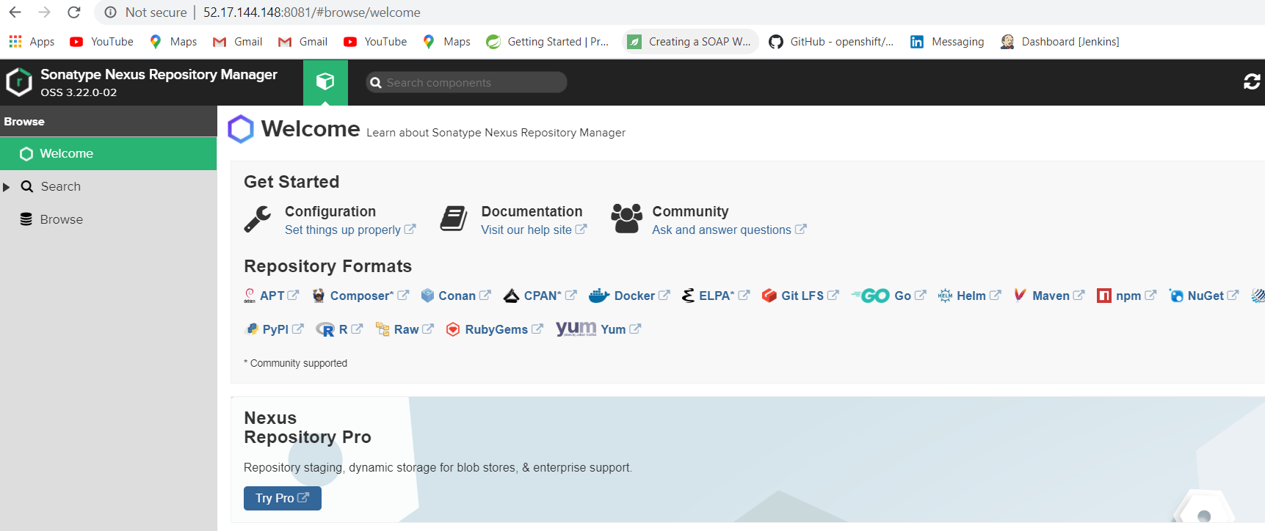

Figure 68 Nexus configured on my ex2 instance

In order to facilitate integration between my nexus server and my application I had to add the following distribution management configuration to my pom.xml file.

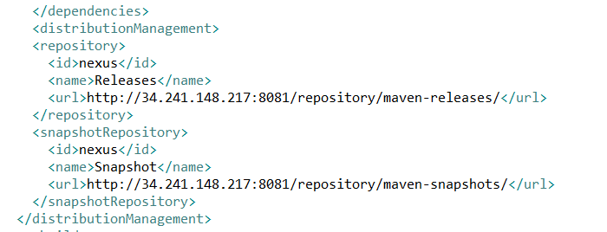

Figure 69 distrubution management configuration info that was added to pom

The above configuration can be got directly from the nexus server and relates to realeases and snaphots. I also added the following settings.xml file in he .m2 folder of my Jenkins build to allow my Jenkins pipeline to interact with my nexus server.

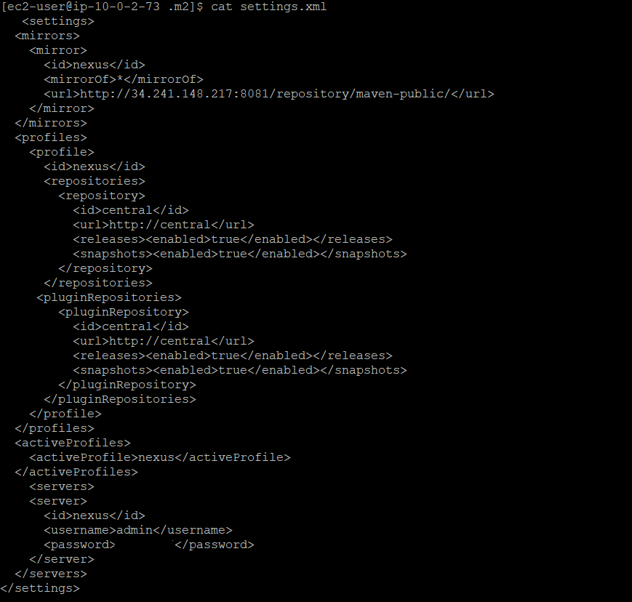

Figure 70 Contents of settings.xml file on Jenkins server

Following completing these steps you have configured nexus to allow Jenkins to interact with it. Now if the lifcycle goal of ‘deploy’ is executed nexus will store you artufacts, dependencys, war of each execution of the pipeline. In this way nexus will store different versions of these sources. Since this is something that I have configured already you can see this clearly in the image below.

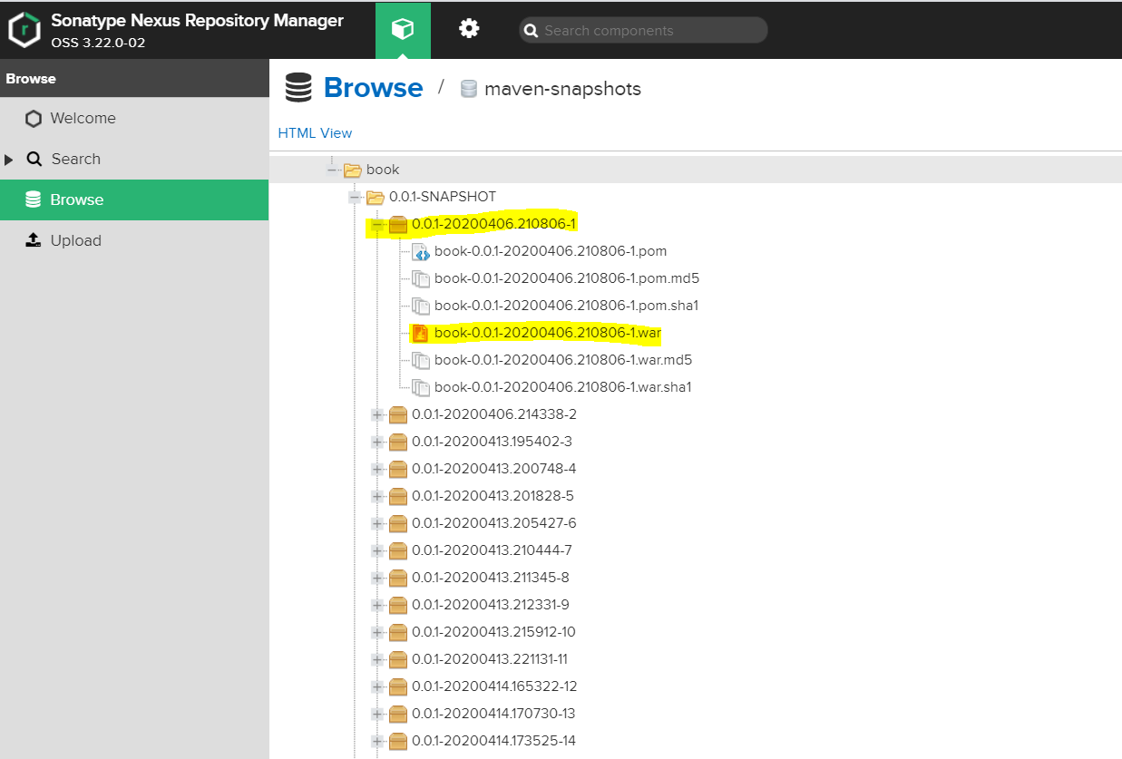

Figure 71 All the different versions of the artifacts that are collected after a deploy each number represents a different version

## Configuring Docker

When trying to get Docker working on the Jenkins, the first attempt was to try and access docker through the global tool configuration page. Here, there is a section for integrating docker into Jenkins as can be seen in the image below.

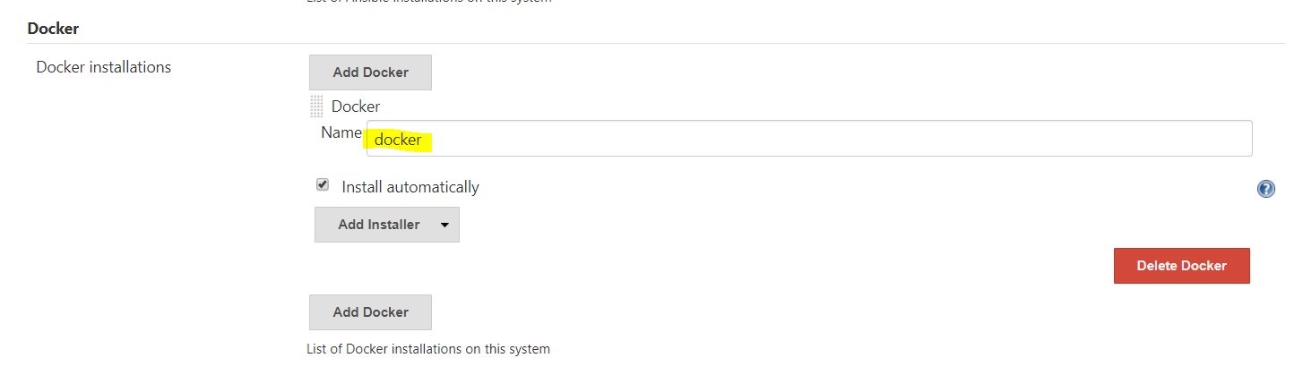

Figure 72 docker section in global tool configuration

However, this did not work as intended and kept producing the same error “Docker command not found”. This error stumped me for a long time and I attempted multiple workarounds as per developers advice on google, none of which were successful. It wasn’t until I came across information buried deep in a stackoverflow thread that the problem may be to do with Jenkins docker installer that I was able to come up with a solution. The solution I came up with was to manually install Docker on my Jenkins server in order to do this I used the following command.



Figure 73 command that was install docker

After downloading docker, the next step is to unzip the folder. After unzipping the folder 8 files will now be present in your directory. The next step is to move the folder so that you can execute docker commands without having to specify the full path.



Figure 74 Command to move Docker folder

Once the folder had been moved, I now needed to start the docker service. In order to start the docker service the following command was used.



Figure 75 command used to start docker service

Once the service has been started, the next step is change permissions on the docker.sock file. The docker.sock file is the main entry point to the docker api and if its permissions are not changed it will throw error everytime a docker command is used. In order to change the permissions of this file, the following command is used.



Figure 76 command used the change permissions

After the command above was issued the Jenkins pipeline is now able to issue Docker commands.

### Containerizing the 3-tiered webservice

This chapter will focus on the Dockerfiles that were created in order to containerize the 3 components that make up the application. The containers will be pushed up on to my online registry as part of the build process and tagged with a version number. The online registry that I am using for this project is Dockerhub. I’d also like to point out that the commands I used to build run and push pull etc will be highlighted at a later stage in the paper.

### Containerizing the CouchDb Instance

The first Dockerfile I created was the CouchDb Dockerfile. The contents of that Dockerfile can be seen in the image below.

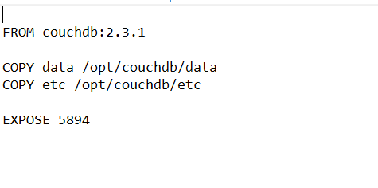

Figure 77 Contents of Dockerfile for CouchDB

The Dockerfile is a set of commands that will be executed in a sequential order in order to containerize a certain process. The first command specificies couchDb and the version of couch. This will serve as the container’s environment. The next two lines copy the following files into the new container. These lines are vital to persistence and every time a container is created all the data of the database will be saved into the new instance. In essence, every build will retain all information that it has up until that point. The final line exposes the port that we want to use in order to access the container. The image below shows the CouchDb container of my Dockerhub registry.

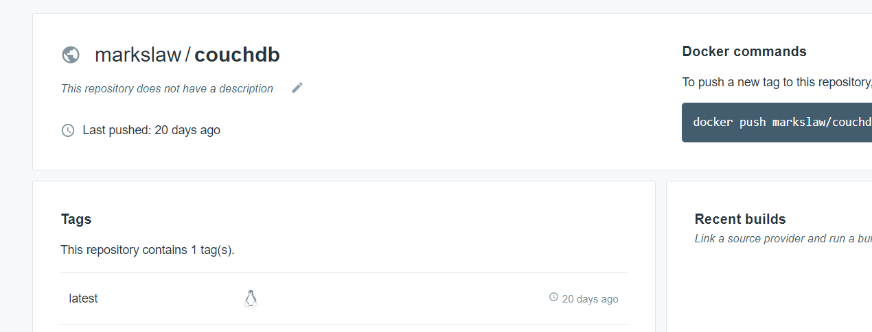

Figure 78 conetnts of my couchDb repository with the latest version being tagged with latest

### Containerizing the Restful Java API

The next Dockerfile that was created was the Dockerfile that would containerize my Java Restful API. The contents of that Dockerfile can be seen in the image below.

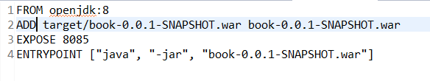

Figure 79 contents of dockerfile in java Restful Api

The first command specifies the build and execution environment of the container on the case above its java 1.8. The 2nd line copies the war file from the target folder to the new container. The third line specifies the port that will be exposed by the container and the final line specifies the war file as the entry point to the application. The docker build command is used in the Jenkins pipeline to containerize the application. The below image shows the repository that the Jenkins file pushes the container too. The tags in the image represent the build number of the pipeline and as is clearly evident, you can see a new version of the container is created every time that there is a new build.

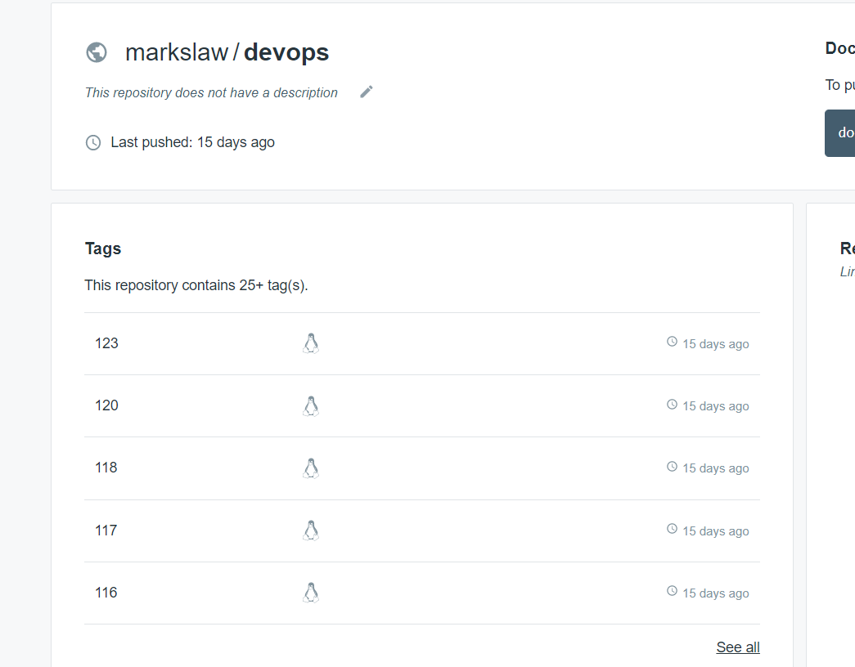

Figure 80 the repository for the restful api. The numbers represent all the builds that have made it to that stage of the Jenkins pipeline i.e all the builds that got passed the quality gate.

### Containerizing the React.js Front end

The final Dockerfile that was created was the Dockerfile that containerized theReact.js front end. The contents of the Dockerfile that was created for this purpose can be seen in the image below.

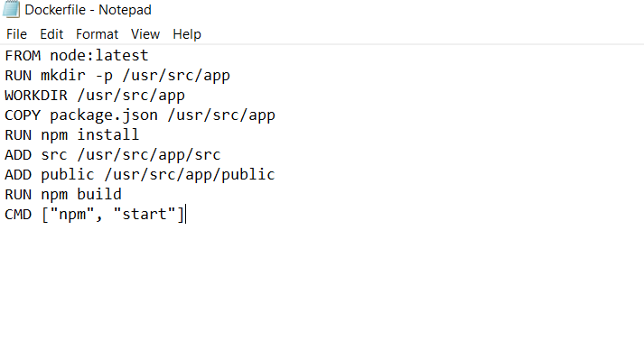

Figure 81 Contents of the Dockerfile that was used for react.js application

As can be seen above, the first line refers to creating a node environment inside the container. The next two lines refer the creation of a folder then assigning this folder to be working directory. After this command, is made the package.json file is copied onto the new container. The package.json file contains all the dependencies that the application needs access to. The run command uses the npm build tool to install these dependencies into the container. After this command is finished executing the next two commands, it copies the 2 folder that are required by the application into the new container. Finally, two build tool processes are executed the first being build which builds the application and the next being start which runs the process.

The container that was pushed to Dockerhub can be seen in the image below. The container was tagged with latest.

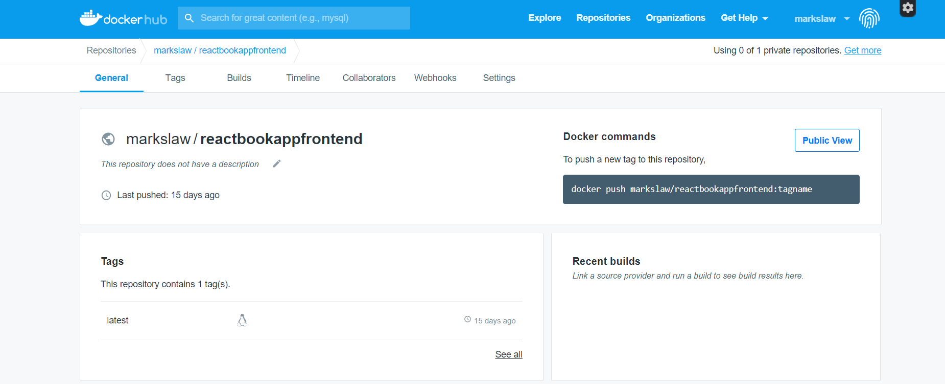

Figure 82 container that was pushed to dockerhub

## 2.9 Production Environment

The next step was to create a production environment that the container would run on. I created an ec2 instance for this purpose. I went with a size of micro as I was planning on using ansible to tear down the environment and recreate it on every build. In this way, I would not encounter any memory issues. The production environment that was created can be seen in the image below.

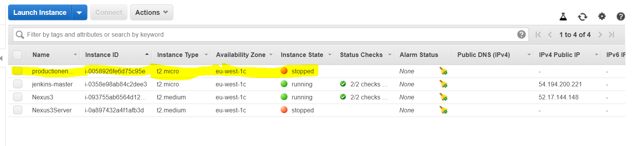

Figure 83 production environment that was created on AWS

## 2.10 Setting Up Slack

To configure slack notifications on Jenkins a Slack plugin is required from the plugins store. Once I got the plugin in the system configuration settings. A new section is now available called Global Slack Notifier Settings. In preparation for this I created an account on Slacks official site and set up a channel for my development team. I then was given a team subdomain and an integration token for Jenkins. I then filled in the form below and Slack was configured on my Jenkins server. The image below shows the details that I entered.

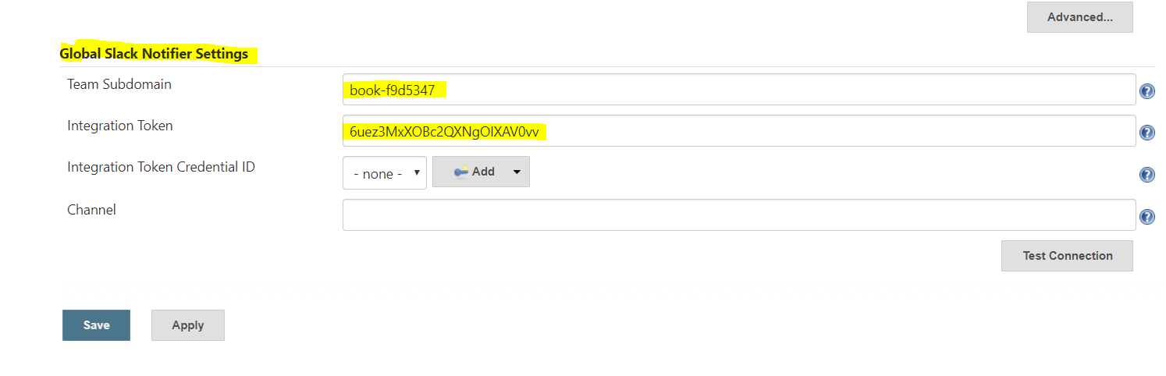

Figure 84 The Global Slack Notifier Settings

## 2.11 Selinium Tests

Selenium Tests were also configured for the pipeline. That uses the chrome driver to automatically launch chrome and test my front-end application. The code for the selenium tests can be seen below.

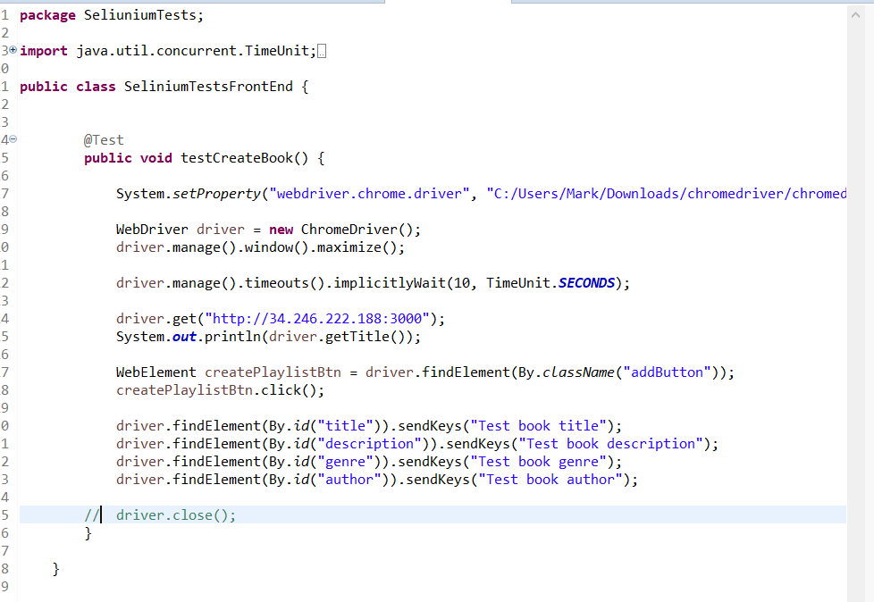

Figure 85 Selinium Tests that were written for the project

Since writhing the selenium tests, I have moved to the cloud and the tests are only configured to work locally, but I demonstrated how they worked locally in part 2 of the video that I submitted for this course.

The reason they weren’t included in the pipeline is because the process of getting a chrome browser into your ec2 was hugely resource intensive and because of the stress that OpenShift put on my ec2 instance I didn’t want to risk owing amazon buckets of money. I just wanted to highlight that my selenium tests do work and they can be view being live demoed in part two of the video that I submitted.

# Chapter 3 Building the Code and Configuring the pipeline

This Chapter will focus on showing us how the tools that were configured in the previous chapter, were integrated int the pipeline and how they allow for CI-CD.

## 3.1 configuring a pipeline jenkins

The next step was to create the Jenkins pipeline. In order to do this, just select create new item from the Jenkins dashboard. After selecting this, give the pipeline a name and just select the pipeline option as can be seen in the image below.

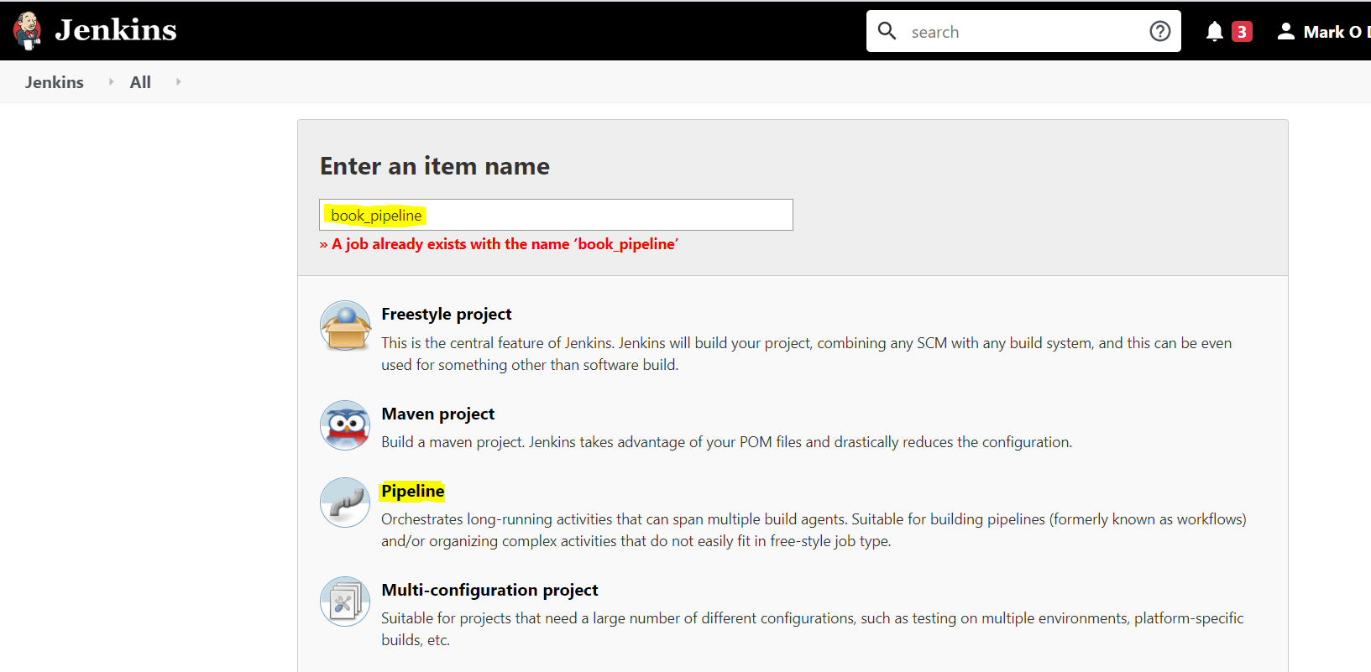

Figure 86 options that need to be selected to configure a Jenkins pipeline

After selecting this option, you will be presented with a list of all potential configuration options. In order to allow for a pipeline, build to be triggered by a commit from a developer we need to go to the Build triggers section. The option that was selected can be seen in the image below.

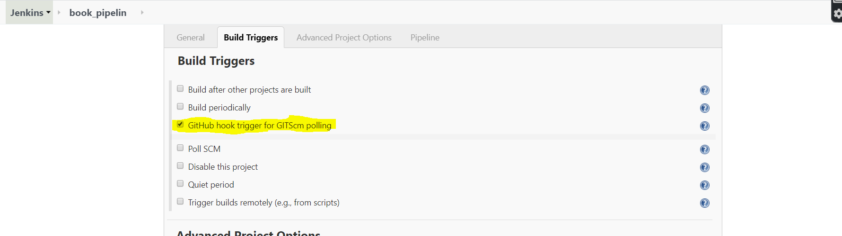

Figure 87 build triggers option that facilitates build triggering from Git Commit

After completing selecting the build trigger, we now need to add my Github credentials so that the project can be accessed and specify the path to the Jenkinsfile. The Jenkins file contains the pipeline definition and anyone familiar with them would be able to infer knowledge of the entire CI-CD stages by reading it. The Jenkinsfile contains the steps need to automate the integration and deployment of an application. We also need to pass in the path to the Jenkinsfile as can be seen by that section my Jenkinsfile is placed at the root of my project.

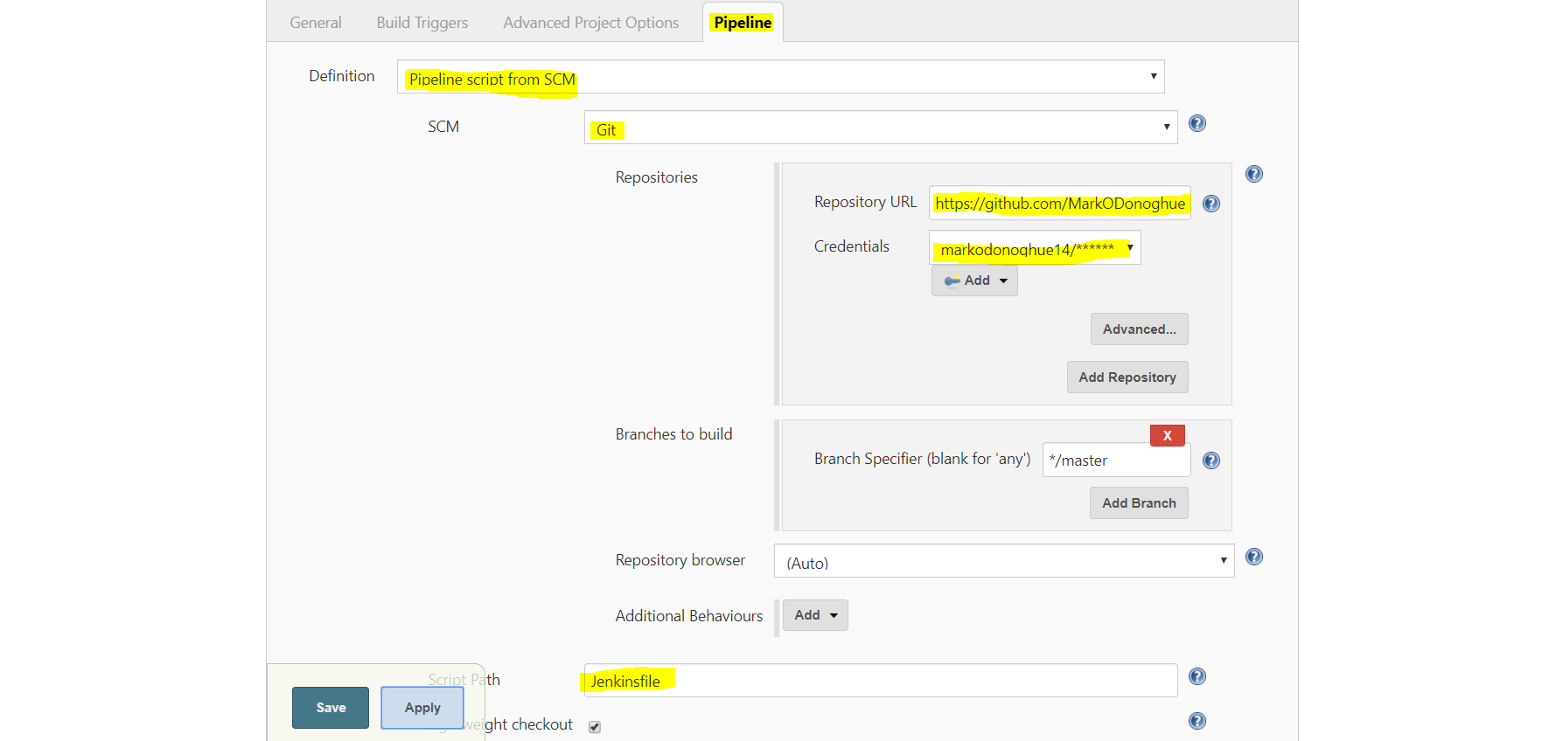

Figure 88 The pipeline options that were selected when configuring the Jenkins pipeline

After creating the pipeline, the next step was to create the Jenkinsfile.

## 3.2 Jenkinsfile

Here I will focus on the stages that were created within the Jenkinsfile. I will just provide a brief outline of the various stages that were created. It is important to note also that stages could have been merged together and achieved to same effect. However, you would be missing a vital aspect of the pipeline if you were to do this. We create this separation of concerns so that we can track exactly where the application fails on the build. In this way, we can isolate potential issues and provide solutions at a much quicker rate then we would have been able to otherwise.

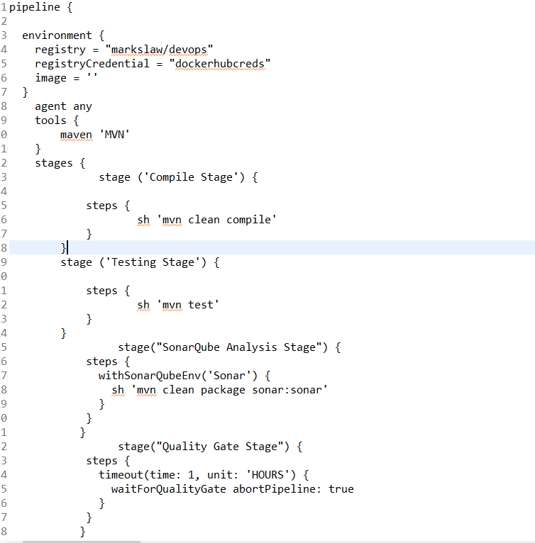

Figure 89 Jenkinsfile part 1

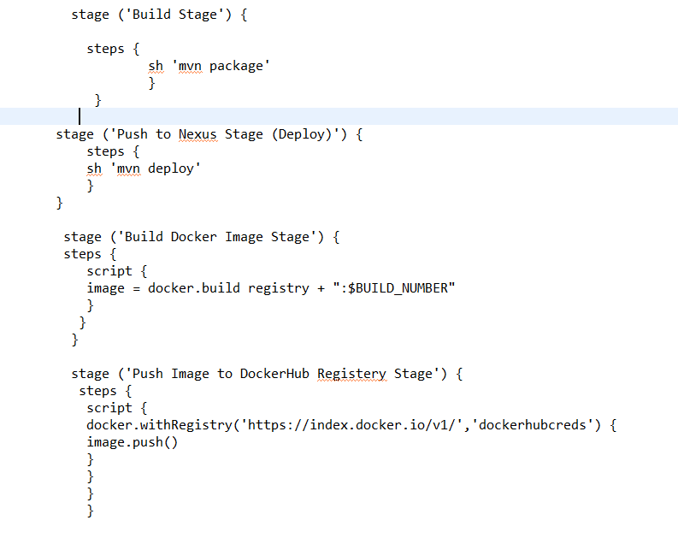

Figure 90 Jenkinsfile part 2

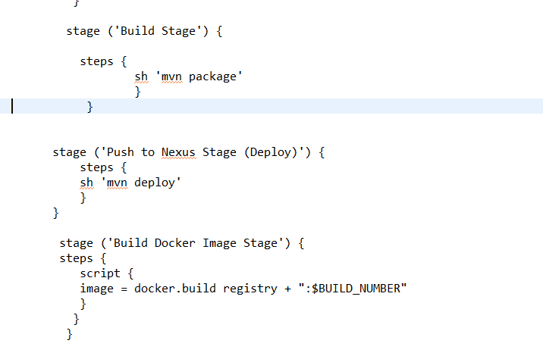

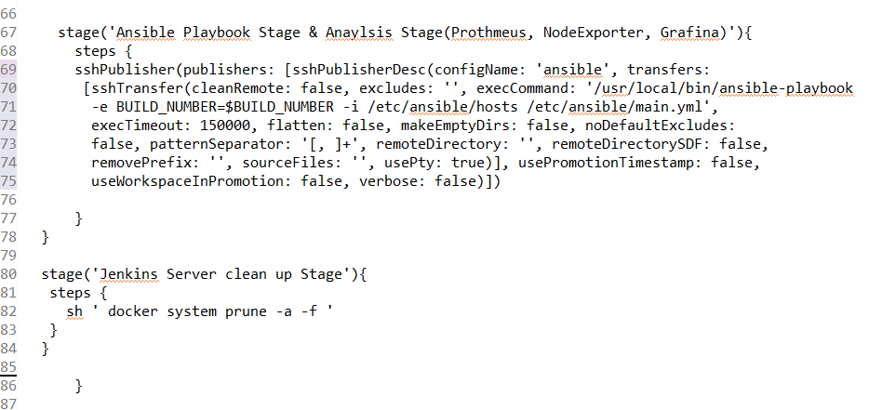

Figure 91 Jenkinsfile part 3

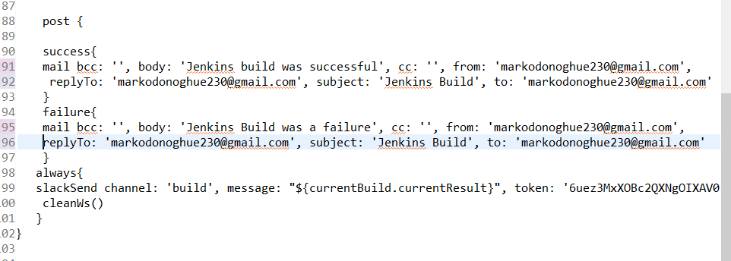

Figure 92 Jenkinsfile part 4

Environment: The environment section of the script simply refers to the environmental variables that I will need. In Jenkins, I specified my credentials to my Dockerhub account and can now access them via this Jenkinsfile. They are needed to push and pull images from Dockerhub.

Tools: This section deals with the global tools that the script needs to access. Since I am using Maven as my build tool, you can see it declared in the tools section. Earlier in the paper you seen me configure the Maven. As is evident from above, the MVN spelling refers to the global tool configuration that I performed on Jenkins earlier.

Compile Stage: Now we are on to the various stages of the pipeline. The first stage is to execute the Maven commands clean and compile. The clean command will flush out the project of any previous builds. The next step will compile the application for us.

Testing Stage: The next stage is the testing stage where the unit tests that were created earlier will be used to test the application. Any unit test that is created in the future will also be executed here.

SonarQube Analysis Stage: The next stage is the sonarqube analysis stage. The command sonar:sonar is used at this stage. The results of the analysis will be available on SonarClouds website which I showed you earlier. In order to facilitate this communication, I had to add the following configuration in Jenkins. The configuration that I added can be seen in the image below.

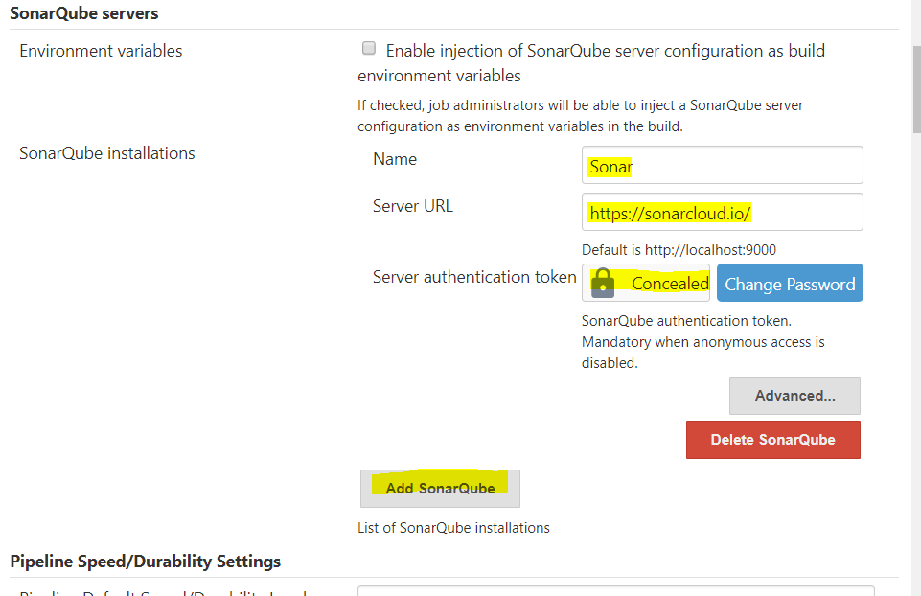

Figure 93 SonarQube server information that was added to jenkins

The above image shows the details that I provide on the SonarQube servers and the relevant detail are highlighted in yellow. Interestingly enough, configuring SonarCloud caused issues and orginally I couldn’t execute the sonar:sonar command from the Jenkins pipeline. Through intensive research online, I was informed that the recent versions of the plugin cause issues with the server. I then reverted the plugin back a few versions to version 2.8.1. After reverting to this version, I didn’t have this issue anymore and the command executed as expected in the Jenkinsfile.

Quality Gate Stage: The next stage is the quality gate stage. The quality gate stage means that Jenkins waits for a JSON payload from SonarCloud. This payload informs Jenkins whether the code has passed of failed the quality gate. If the code fails, the quality gate the build is aborted and deemed to have failed. If it passes the quality gate the pipeline executes as normal.

Build Stage: The next stage of the pipeline is the build stage. This stage packages the entire application into a war file. This is facilitated by the package command.

Push to Nexus Stage (Deploy): This stage used the deploy command to deploy the application to Nexus. This stage makes use of the setting.xml file that I showed earlier, as well as the dependencies that I showed earlier in my pom.xml file.

Build Docker Image Stage: This stage uses Docker commands to build a docker image and tag it with the Jenkins build number. It will use the war file that was just created by the package stage and add it to the image.

Push Image to DockerHub Registery Stage: At this stage, the docker container is now pushed the Dockerhub repository. It has already been tagged by the build stage and is awaiting Ansible to pull it back down. At this stage all new changes have been successfully added to the project and it has been containerized and each container version controlled by way of the repository.

Ansible Playbook Stage & Analysis Stage (Prothmeus, NodeExporter, Grafina): This stage deals with executing the commands that are found in my ansible playbook. This playbook script tears down the previous environment, creates a new environment and deploys the 3 containers to this environment. It then also manages and launches metric gathering and displaying tools. In order for this stage to be accomplished however, more configuration was going to be needed on the Jenkins server to facilitate this. First a plugin called publish over ssh is needed. After getting the plugin, the following information needs to be added to the SSH server section.

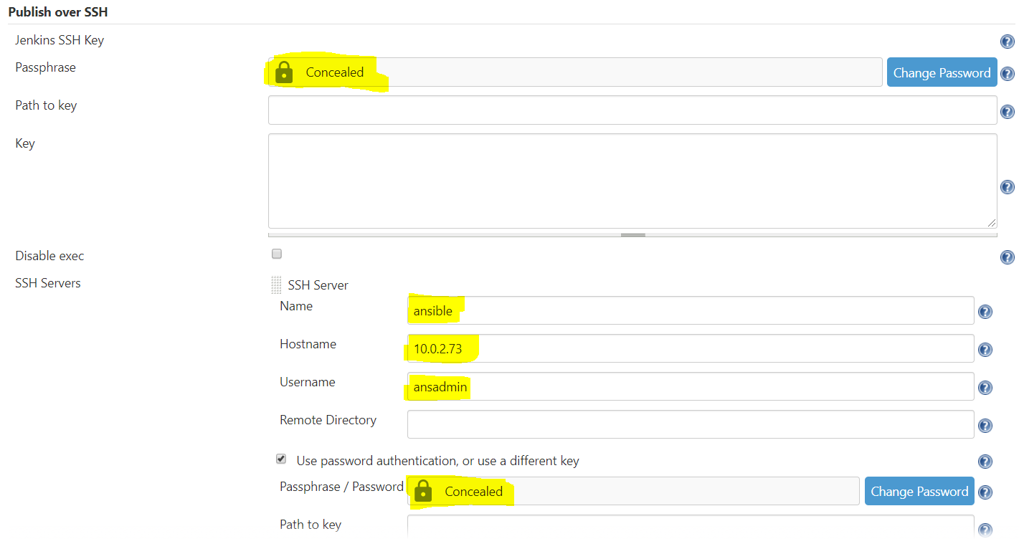

Figure 94 ansible configuration in Jenkins part 1

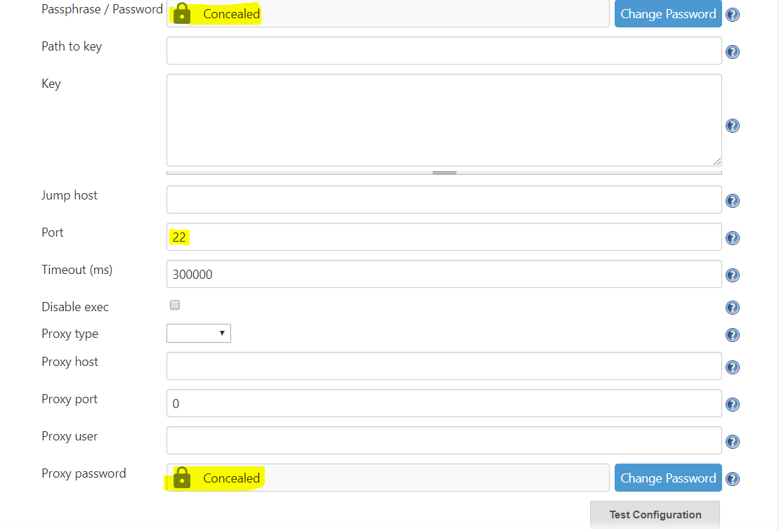

Figure 95 ansible configuration part 2

The areas highlighted in yellow are the information that I provided but the key to its success is adding that Ansadmin user that will be created when I discuss implementing Ansible.

Jenkins Server clean up Stage: The next stage in the pipeline is to perform some clean up on the Jenkins server after the whole process has finished. For this, the docker prune command is used which will clean out any container or dependencies that may have accumulated. This stage is good practise in general as you are wasting memory on your ec2 instance but was vital for me. The Jenkins server needs all the memory that it can get and was had previously thrown an out of memory error when testing previous builds. Once this stage was added, I didn’t encounter the error again.

Post: The final bit of the pipeline falls under the Post tag. What this means is that post build, if certain conditions are met an action will be performed. As is evident from the images of the Jenkinsfile above, if the build is successful or a failure a different email will be sent to the developer who committed the code informing them of this. A slack notification will always be sent to the team’s channel informing them of the success or failure of the build.

# Chapter 4 End-to-end automation of the project’s configuration management and continuous delivery orchestration

This Chapter will focus on how Ansible was set up and the full integration configuration management and continuous deployment of the project.

## 4.1 Setting Up Ansible

Ansible was used for system configuration management, cd and orchestration of the environments. I set up Ansible on the pre-existing ec2 instance that was used for Jenkins. This decision was made purely from a monetary perspective as previous attempts with OpenShift had shown me how easily large expenses could be incurred. The first step to setting up Ansible was to use the following commands.

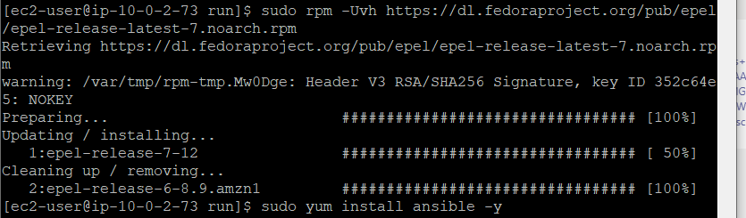

Figure 96 Commands used to install Ansible

After installing, the next step is to create a use called ansadmin.



Figure 97 adding ansadmin user

After creating the user, the next step is to grant this user access. In order to grant the user root access, the sudo file needs to be modified as seen below.

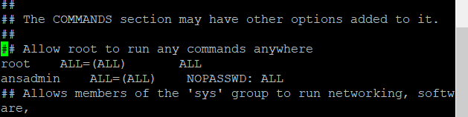

Figure 98 Giving root access to ansadmin user

Now that the ansadmin user has been given root access the ansadmin user is able to run any command without running into any permission errors. This was a very important step as a lot of the commands in playbook need these permissions. The same user was created on the production environment following the steps listed above. This was needed so that when the ansadmin user tries to connect with the production server, he will have root access there also and will be recognized by both servers.

Since ansible is responsible for tearing down the old environment configuring all the tools needed, deploying and orchestrating the deployment of my application, it was vital to allow for communication between my Ansible server and my production server. In order to allow for this, the first step was to generate an ssh key. The following command was used to achieve this.

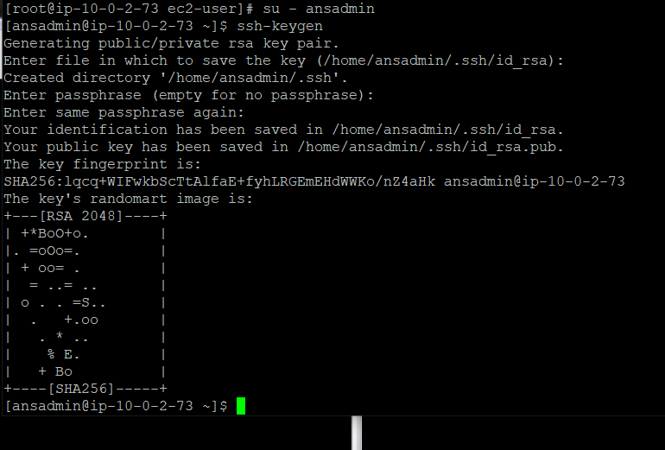

Figure 99 generating the ssh key on the Ansible server

As can be seen in the above image, a public and private key are generated to allow for secure communication between my servers. The next step was to copy this key into the production server. I achieved this by using the following command.

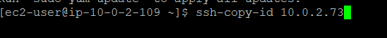

Figure 100 command that was used to copy key to production server

As can be seen from the above image, the servers private IP address was used to transfer the key.

The next step was to create a file called hosts that will keep track of all the servers that Ansible will communicate with.

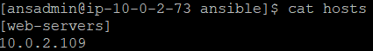

Figure 101 Contents of hosts file

In order to confirm that Ansible has established a connection with the production server, the following command was used to test this communication. The server says ping and if communication has been established the hosts will respond with pong.

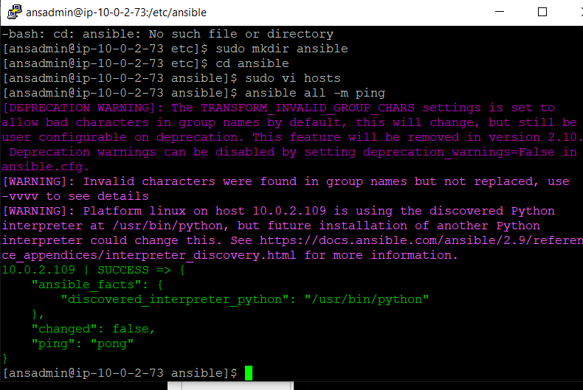

Figure 102 connection established between server and hosts

After establishing the connection, the next step was to create my ansible playbook script. The playbook was used for a variety of reasons and really demonstrates the power of ansible. For instance, I used ansible for system configuration management, continuous application deployment as well as container orchestration.

## 4.2 Setting Up The Ansible Playbook

The Playbook .yml file is integral to being able to provide this functionality. A playbook is a list of commands that are executed in sequential order. The playbook that I created is called the main.yml and can be seen in the images below.

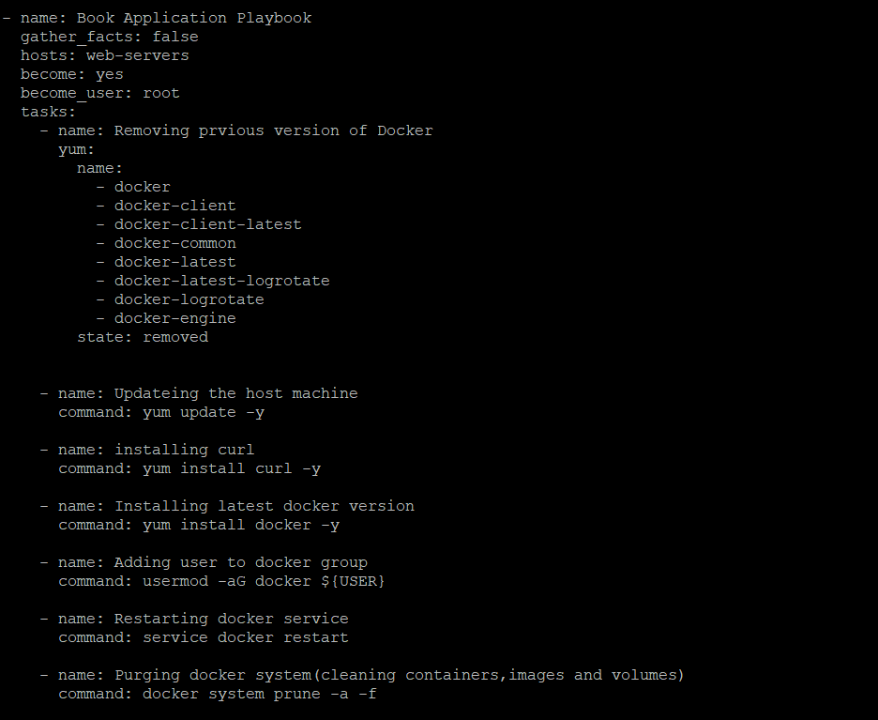

Figure 103 Contents of the Ansible Playbook file (main.yml)

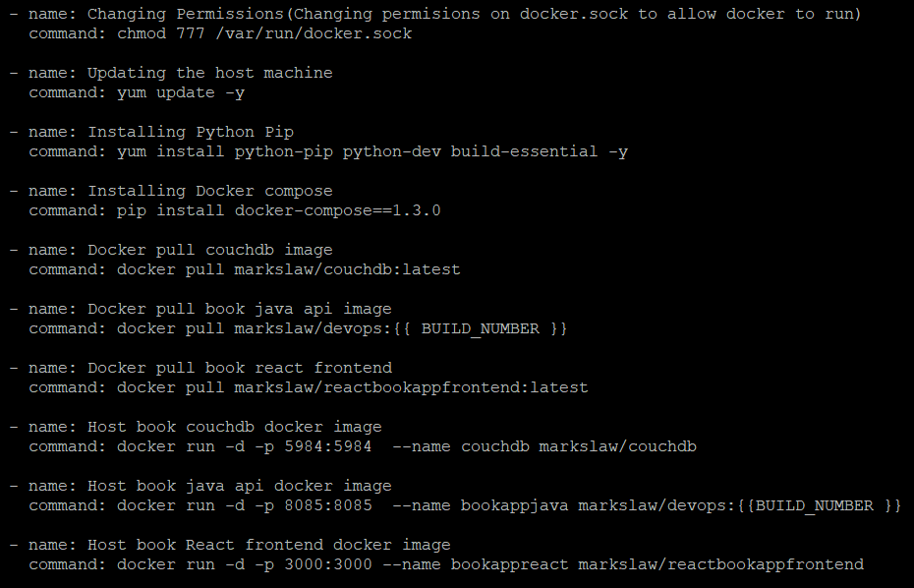

Figure 104 Contents of the Ansible Playbook file (main.yml) part 2

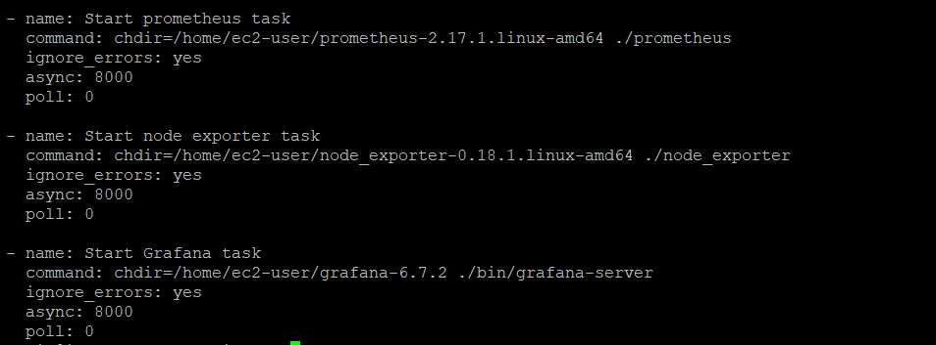

Figure 105 Contents of the Ansible Playbook file (main.yml) part 3

Set Up: The set-up part of the script provides a lot of functionality. In my script, I specify my hosts which is the we-servers we seen in my host file earlier. This marks the production server as the host. The next step is to allow the become functionality to be added. The become_user then gives the script root access.

Removing previous version of Docker: The first command completely removes all the docker packages that are on the system. The first time this is ran, there will be nothing there as the environment hasn’t been set up yet but on every execution of this script following the first one it will tear down the docker environment.

Updating the host machine: This command will update all installed packages on the system.

Installing curl: The next command will install curl on the target system.

Installing latest docker version: The next task will install the latest version of docker on the host system.

Adding user to docker group: This command will add the user to the docker group.

Restarting docker service: This command will perform a restart on the docker service.

Purging docker system (cleaning containers, images and volumes): This command was added because of a bug that I discovered while working with Docker. The bug is well documented on google but what happens is when you set up a new docker environment and add a user that docker recognizes, it will sometimes and I stress sometimes pull-down old images and containers. Although theses containers would never have never been run however, the worry would be that overtime this could cause resource issues. The purge command accounts for this as it will completely clean the docker workspace. It cleans out all containers, images and volumes.

Changing Permissions (Changing permissions on docker.sock to allow docker to run): This command will change the permissions on the docker.sock file to allow access to it. This vital to allowing access to the docker API.

Updating the host machine: This command will update the host machine packages

Installing Python Pip: This command will install python pip

Installing Docker compose: This command will install Docker compose

Docker pull couchdb image: This command will pull down the CouchDb container that was created using the Dockerfile that was previously talked about. Then, container persists the current data every time that it is built. In this way, docker is providing persistence to my data as each container will have different versions of the data.

Docker pull book java api image: This command will pull the Java Api container that corresponds to the latest build. This is possible through using Jenkins build number as a tool to tag the image. This same number is then used to pull the corresponding image back down from Dockerhub. Since in each build, the package command is used and the war file is updated every time a developer commits a change, that change is containerized and deployed on my production server. In this way, changes are not just integrated but the process of deploying it is fully automated.

Docker pull book react frontend: This command will pull down the latest docker image in relation to my react container. I already showed earlier how my react application is containerized.

Host book couchdb docker image: This command will run the couchdb container that was already pulled down by the ansible script.

Host book java api docker image: This command will run the Java Api container that was already pulled down by the ansible script.

Host book React frontend docker image: This command will run the React container that was already pulled down by the ansible script.

Start Prometheus task: This command will start the Prometheus metric gathering tool. These tools will be discussed further in chapter 5

Start node exporter task: This command will start the node exporter metric gathering tool. These tools will be discussed further in chapter 5

Start Grafana task: This command will start the Grafana visualization tool. These tools will be discussed further in chapter 5

As can be seen above, Ansible is very powerful tool. The process of creating my environments is completely automated. So, too is the process of getting the latest versions of my applications that are packaged then containerized and run on the production environment. In this way, code changes are taken directly from git, analyzed etc and then deployed into production without any manual intervention. As well as this, if I lost all my servers tomorrow and everything was gone, I could use the above script to have everything back online in 2 mins without any manual intervention. The script takes 2 minutes on average to execute so that is why it takes that time.

## 4.3 Full Process

Now, we will focus on a look at the build start to finish. We will look at the various tools and deployments of the applications in order that they happen then I’ll show that this was all from my Jenkins pipeline by showing the dashboard. When the developer commits to git, a build will be triggered. This process was already demonstrated on the video that I submitted as part of this assignment. It shows that it is in fact a git push that triggers the build and not polling or some other similar means. The screenshot below shows that the Github webhook is successful.

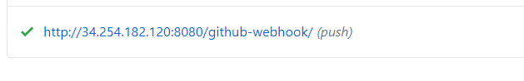

Figure 106 Github webhook working successfully

The next image shows that the SonarCloud webhook was successful also.



Figure 107 shows the SonarCloud webhook is successful

The next image shows the Analysis that the Sonar did on the application as well as the fact that quality gate passed.

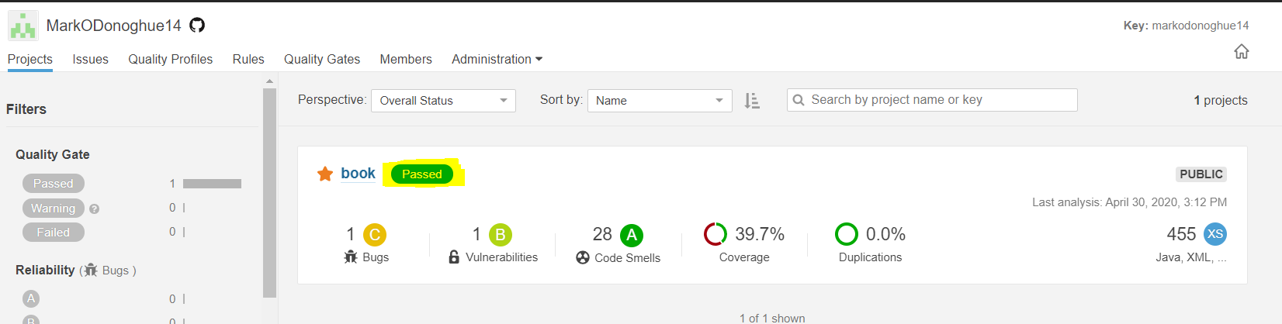

Figure 108 SonarCloud quality gate passing

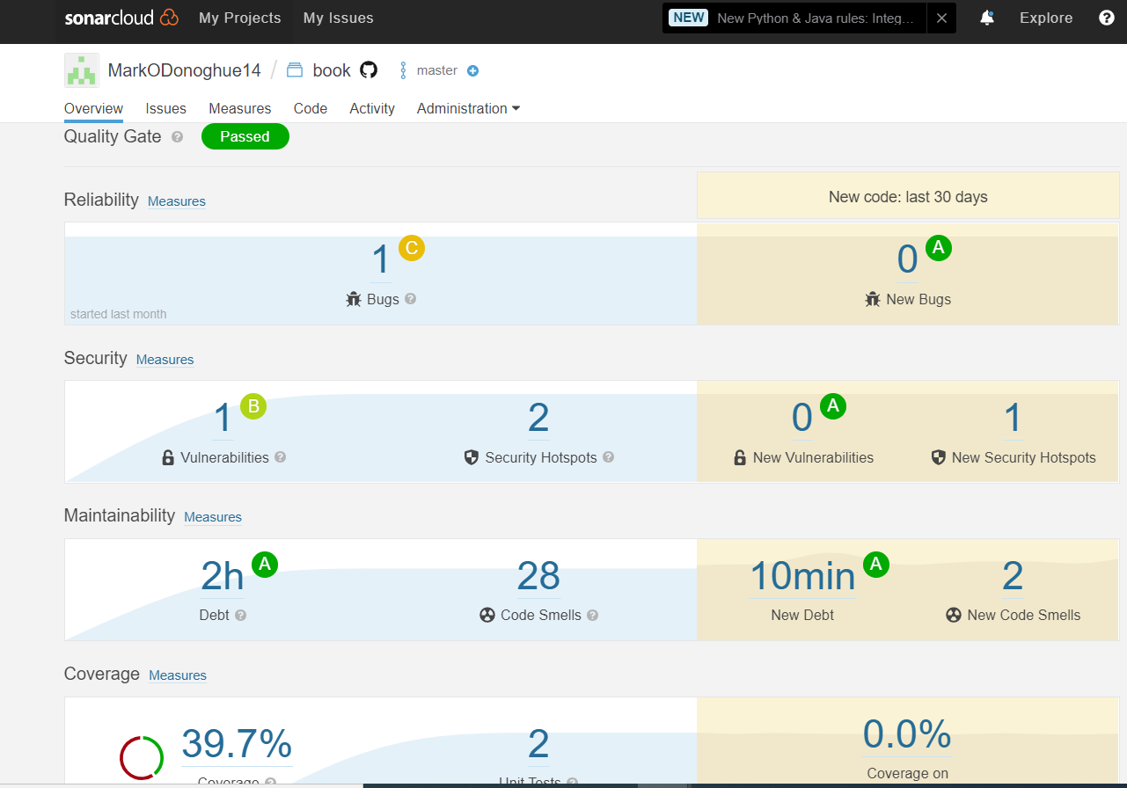

Figure 109 shows some of the analysis that is performed on the application

The next screenshot shows the project artifacts that were deployed to Nexus plus the IP address of the hosted Nexus server.

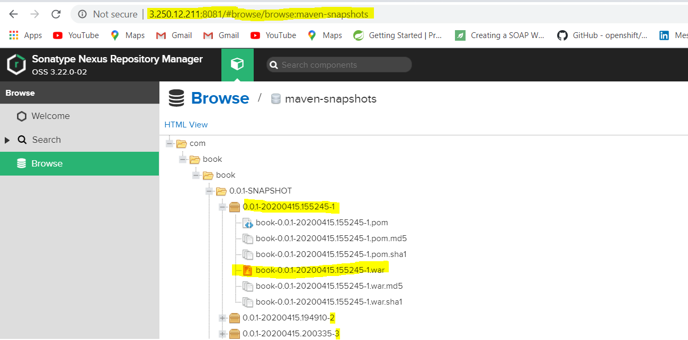

Figure 110 Screen of project artifacts versioned in my Nexus repository.

As can be seen, all the dependencies and war are collected by Nexus and new version is collected on every build. The next images will show the 3 application in the Dockerhub repository. I’ve highlighted the repos for this project this is my personal repo so I have more images than that in there.

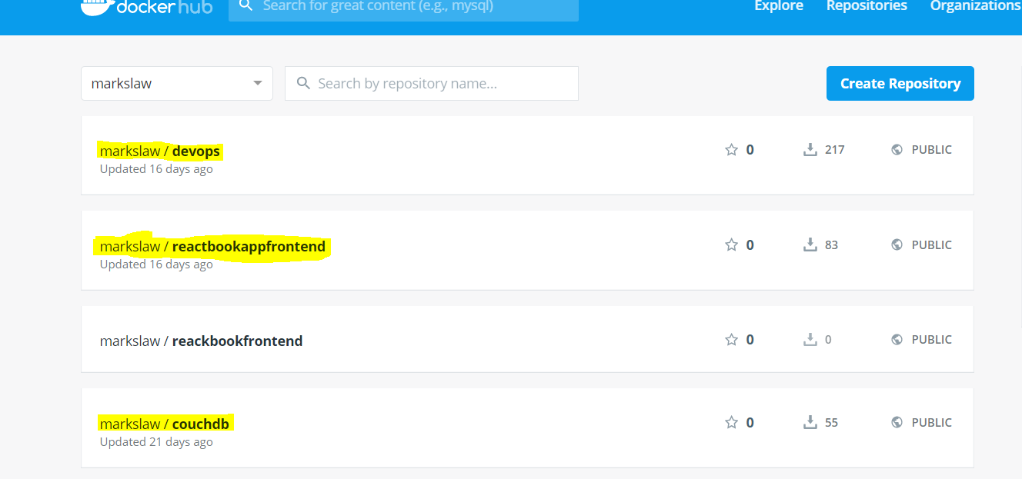

Figure 111 Dockerhub image showing 3 images

The image below shows the image of the Devops Repo that houses the containerized Restful java Api’s. As is clearly evident, each container that is present has been containerized with the Jenkins build number. I have highlighted the 123 tag because I intend on showing that at the end of this chapter showing that a successful build has led to application being containerized and sent to Dockerhub.

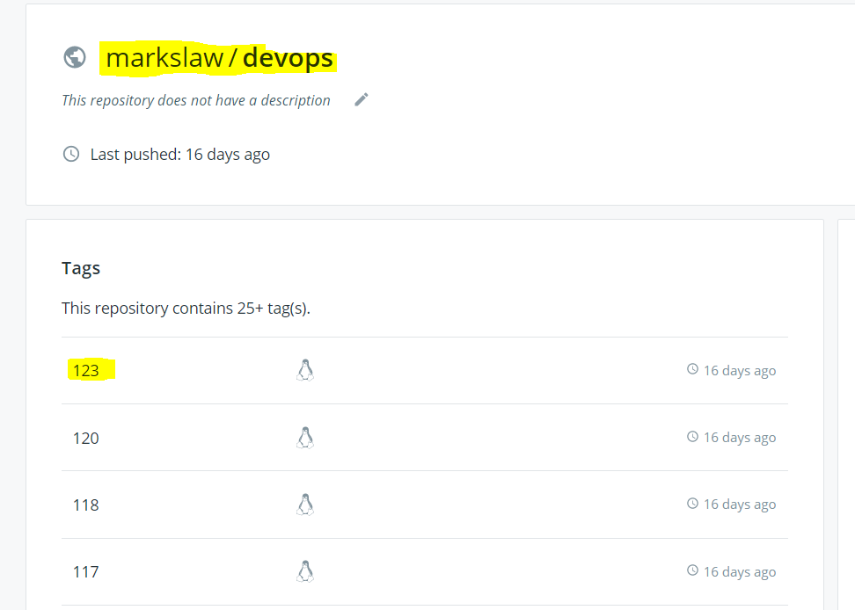

Figure 112 shows the images that are in the DevOps repo

The next image shows the CouchDb container running in the production environment.

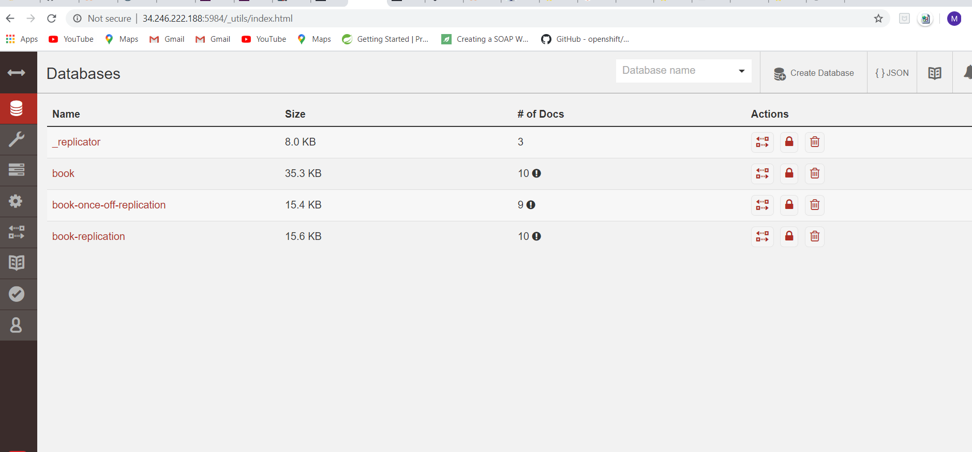

Figure 113 CouchDb instance hosted on production environment

The next image shows that my Java Api being hosted on my production environment. The image shows one of the Restful endpoints being hit and producing JSON objects that are coming directly from my CouchDB instance which is also hosted.

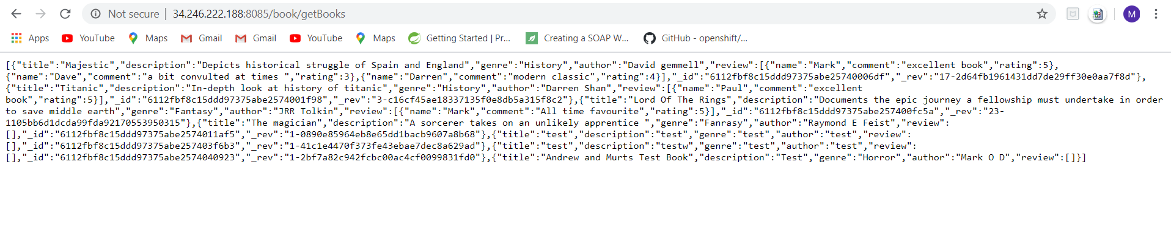

Figure 114 Hows the results of hitting the javaApi endpoint.

The next image shows the react application that is hosted on the production server, this can be seen from the IP address and the port that it is listening on. The data that is being displayed on the screen comes from CouchDB, passes through my API and then is displayed on my React Front end. If you look closely the data matches from start to finish i.e. from couch to React.

The images below show the console logs of the build showing that the Ansible playbook commands that I showed you in this chapter have been successfully executed.

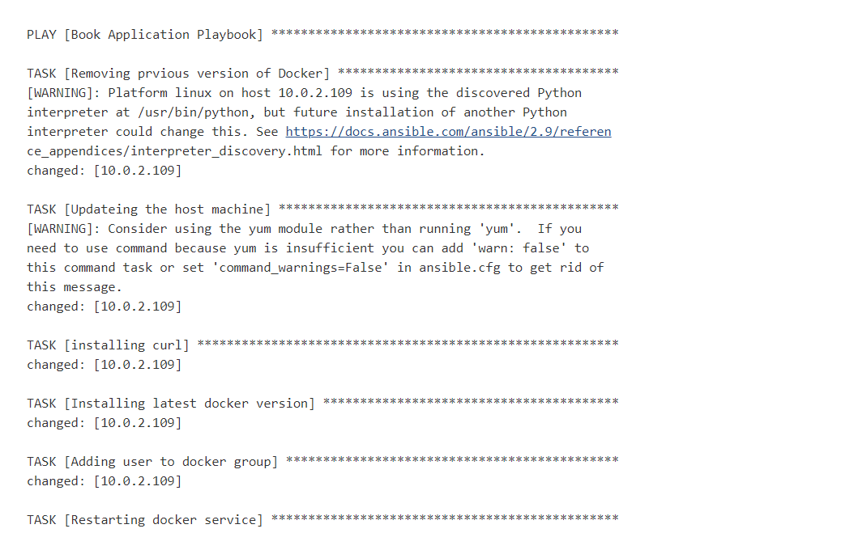

Figure 115 ansible commands being executed part 1

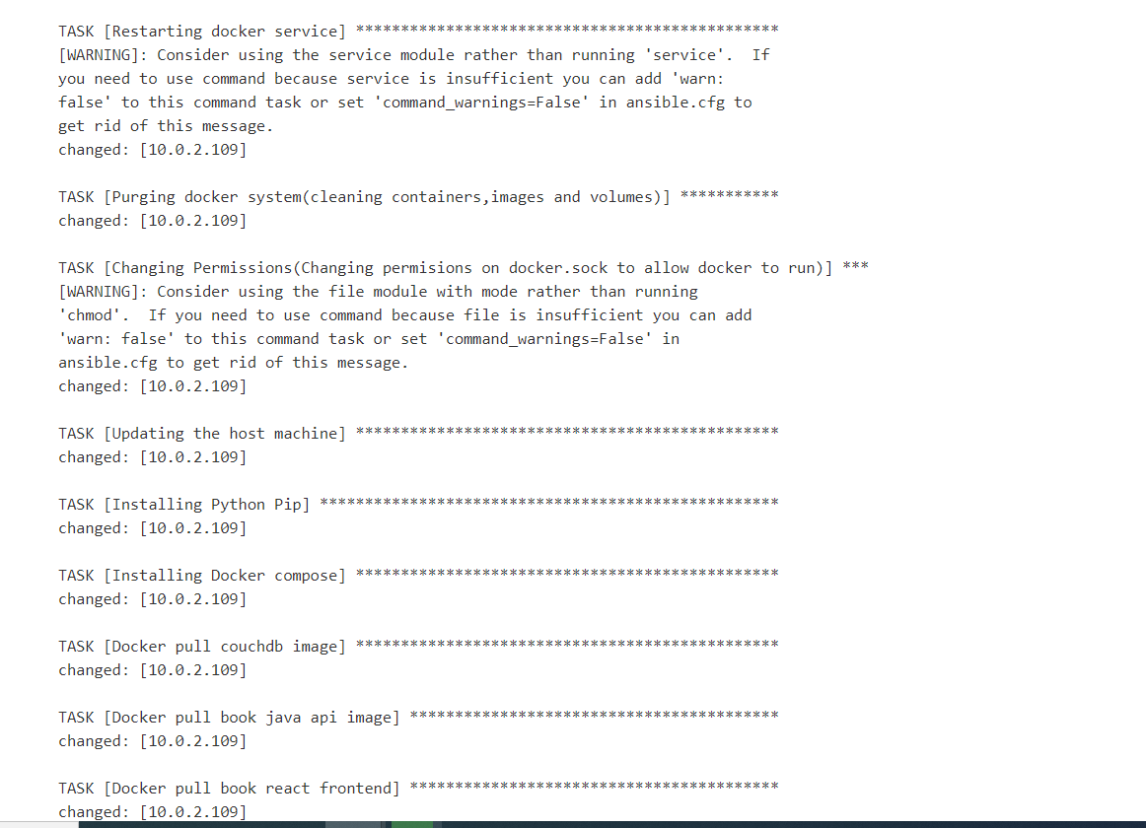

Figure 116 ansible commands being executed part 2

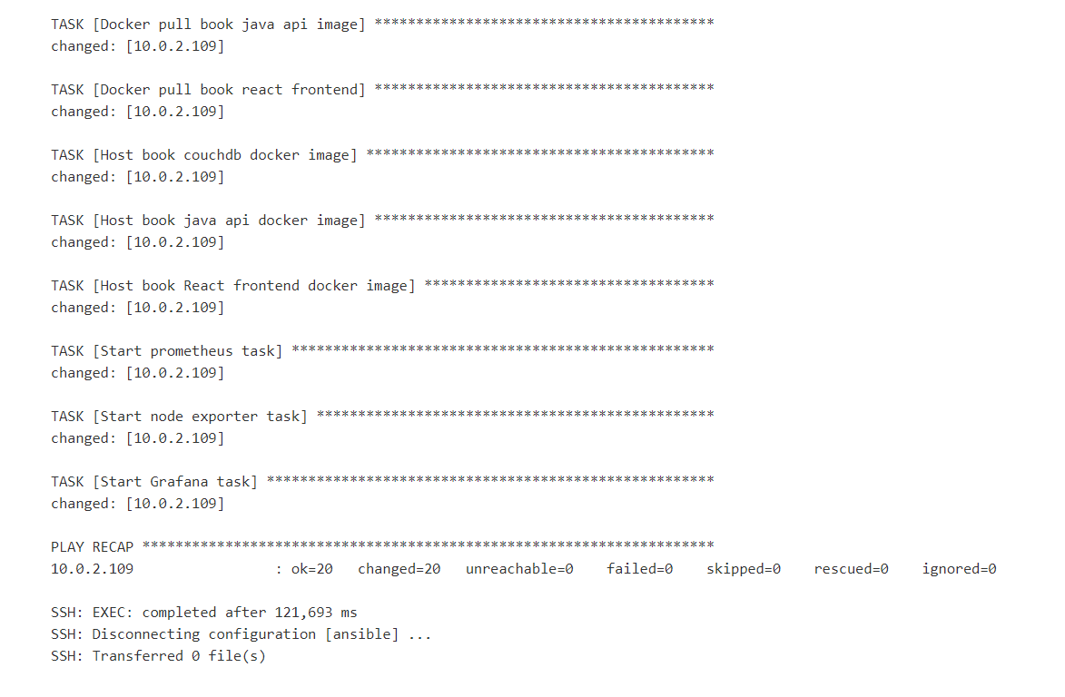

Figure 117 ansible commands being executed part 3

As is clearly evident, the ansible playbook script executed without any issue. Next, I will show just the logs on Jenkins from the testing phase just to show that they have executed correctly.

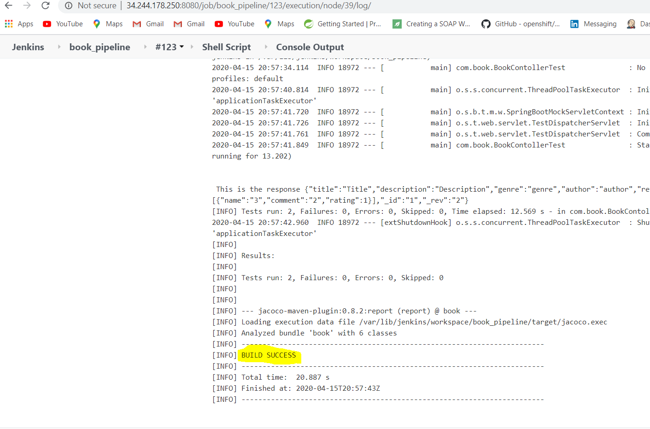

Figure 118 logs from the test scripts

Now, I will show you that the entire pipeline that I have outlined in the previous chapters and will outline more of in Chapter 5 is working. I also would like to point out that when I showed you the Dockerhub registry, the container was tagged with 123 that corresponds exactly to the pipeline I show below.

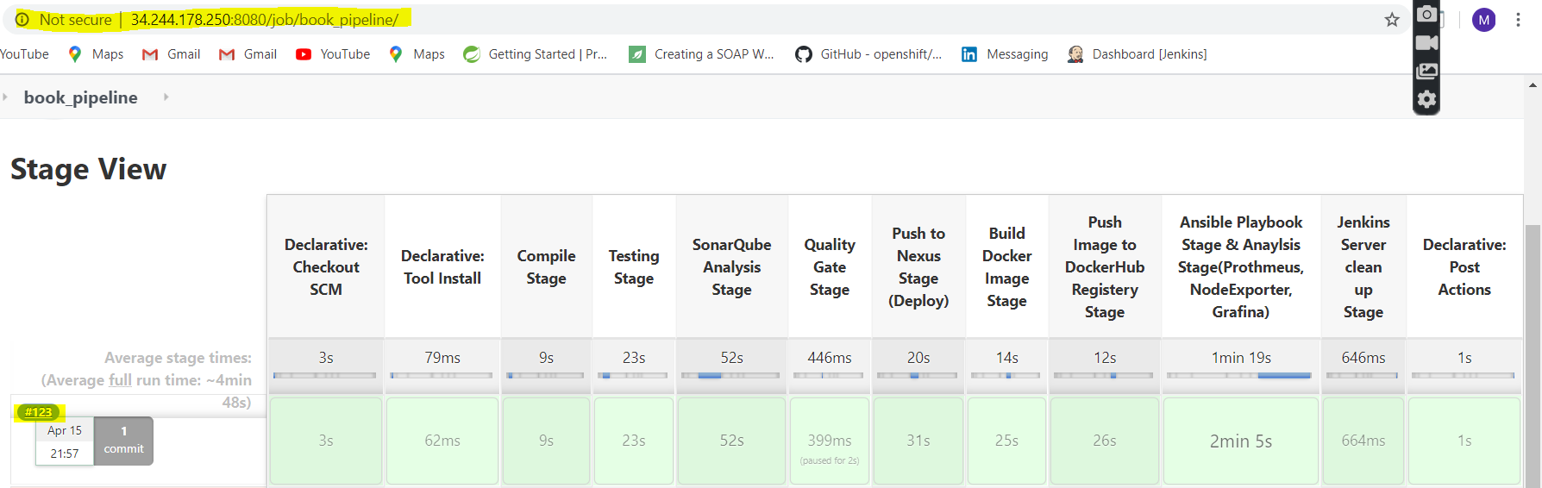

Figure 119 image of the Jenkins pipeline showing the Ip address and the build number

The next image is just a close up because the image above is hard to see.

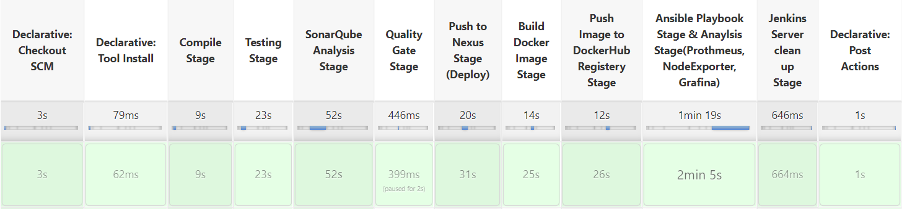

Figure 120 Close up image of the J enkins pipeline

Now I just want to highlight that in the declarative post actions stage an email is sent and a slack notification is sent. This is evident from the logs below.

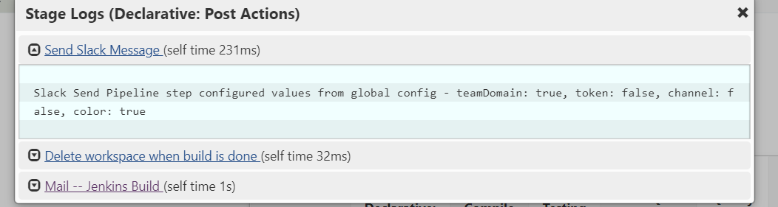

Figure 121 Log from the Post Action Stage

As can be seen a message and email were sent the contents of the notification and the email can be seen below.

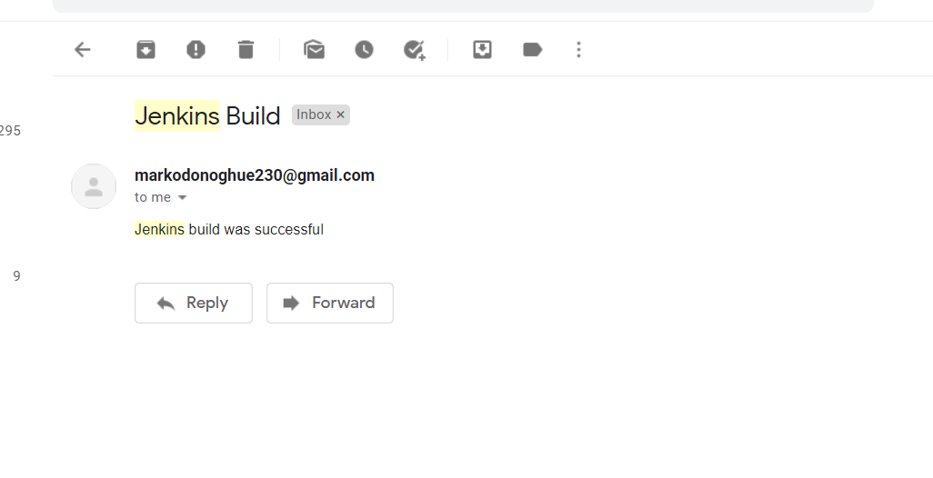

Figure 122 email that was sent from Jenkins after pipeline was successful

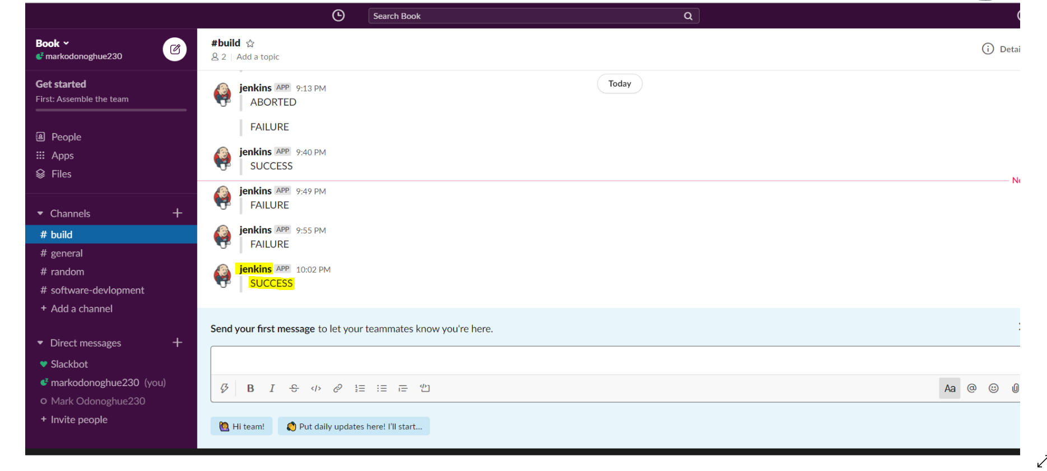

Figure 123 Slack Notification that was sent the highlighted one corresponds to build shown

Finally, I just want to show an image of what the pipeline looks like If I intentionally fail the quality gate. This can be seen in the image below.

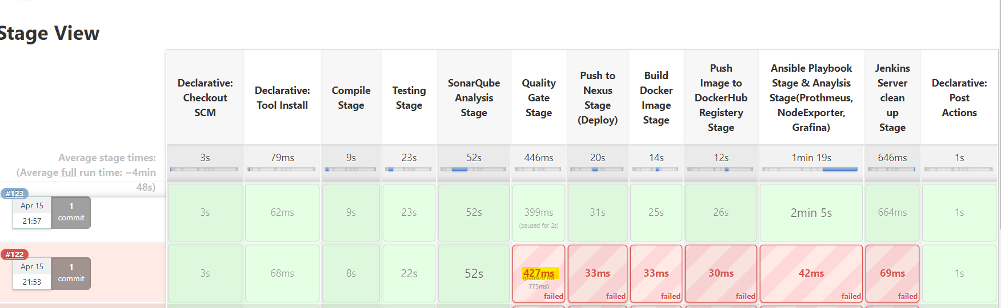

Figure 124 build 122 intentionally failing quality gate

If we look at the logs of that failed quality gate, we can see that SonarCoud sent a JSON payload to Jenkins informing the server that the quality gate had failed.

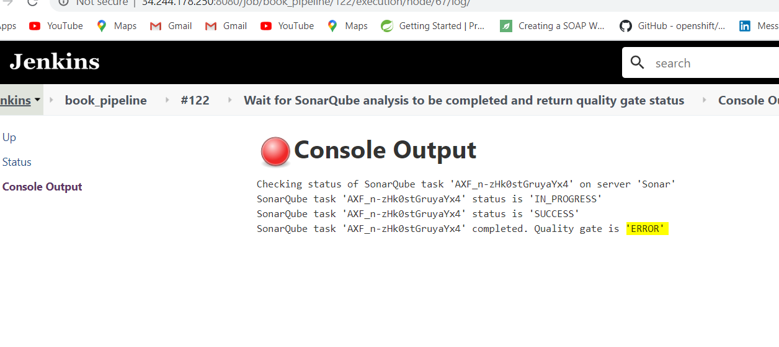

Figure 125 image of the logs of the failed quality gate

At this stage I have demonstrated the end to end automation of the entire application. However, I still just need to show you how I configured the metrics.

# Chapter 5 Monitoring Infrastructure & Application

## 5.1 Metric Gathering Tools

This chapter will focus on the metric gathering tools that were used those being Prometheus and Node_Exporter, as well as the visualization tools Grafana that were incorporated into the project.

## 5.2 Prometheus

I started by configuring Prometheus on my production environment. In order to do this, I ssh’ed into the ec2 instance. I then used the following command to get the Prometheus packages that I needed.

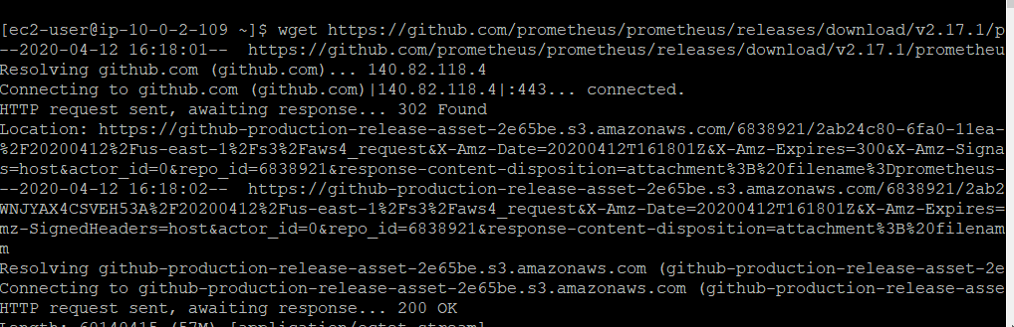

Figure 126 the command that was used to get access to the Prometheus packages required

After downloading the zip file, the next step was to unzip it. After unzipping the folder, the following command can be used to start Prometheus.

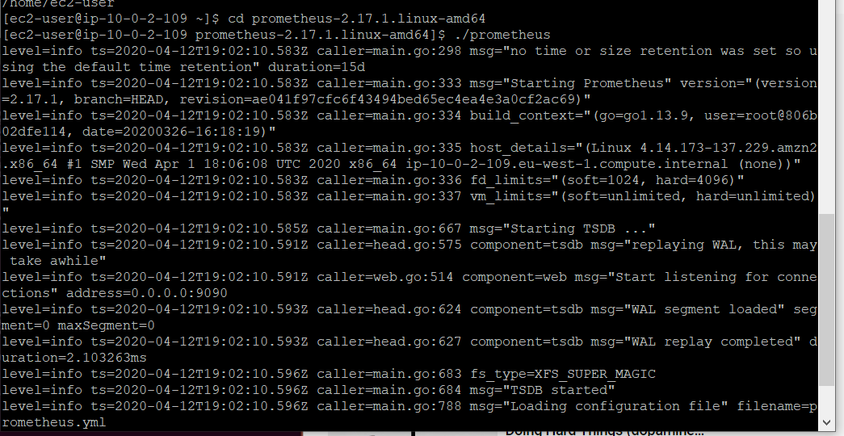

Figure 127 Starting Prometheus

After starting Prometheus, you can view if it has been successfully installed by using the production servers IP address and the port number. Prometheus working on my production server can be seen in the image below.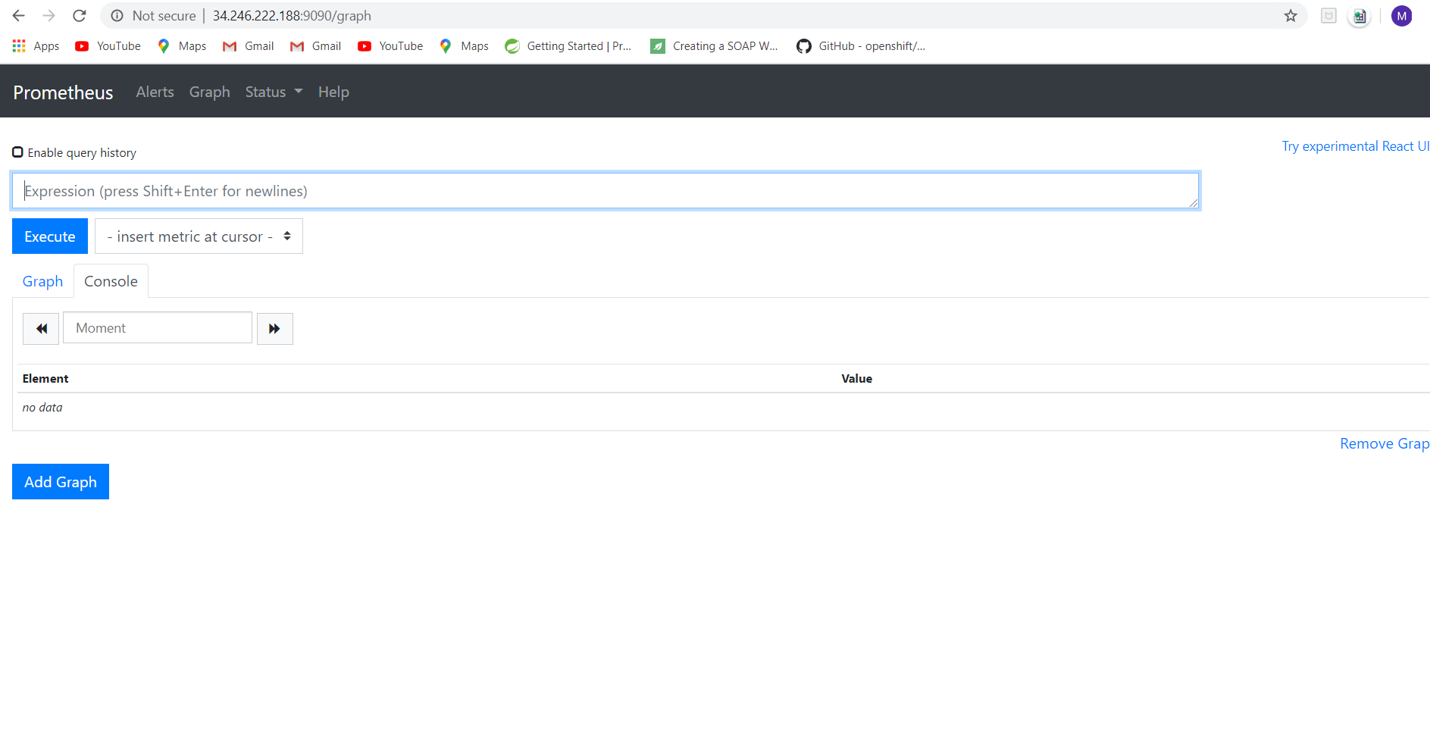

Figure 128 Prometheus hosted on my production server

## 5.3 Node exporter

After configuring Prometheus, the next step was to set up another metric gathering tool called node exporter. To install this tool, the following command was used.

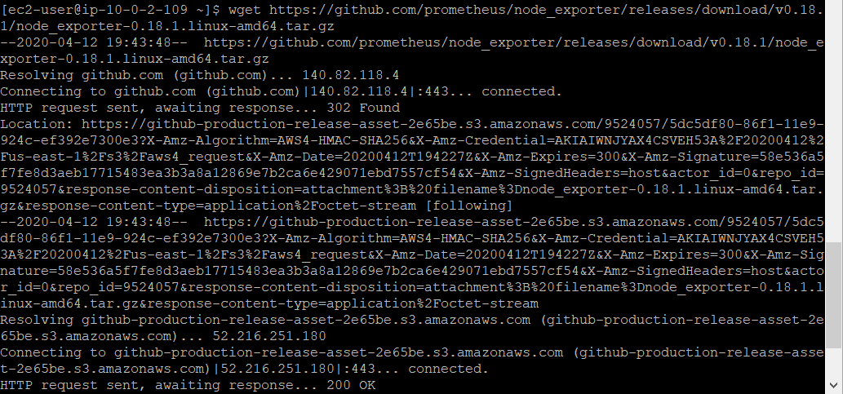

Figure 129 command used to get node exporter

After, getting the zipped node exporter package to next step is to unzip the files. After unzipping the files, the following command is used to start the service. The command can be seen in the image below.

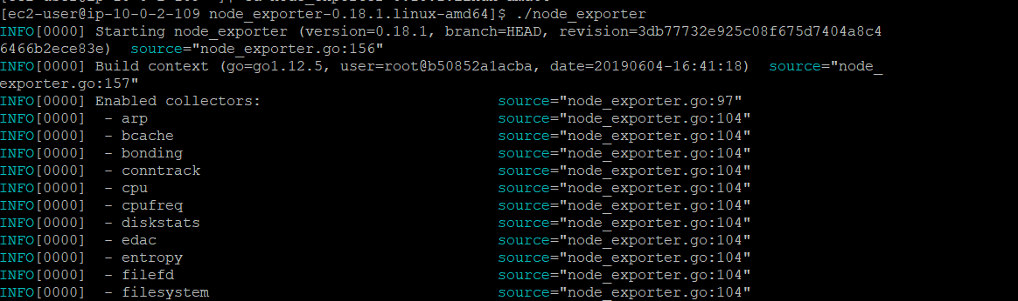

Figure 130 starting node exporter

Now, all you need is the public IP address of the ec2 instance and the port number that it listens on, to see it on your ec2 instance. The image below shows node exporter on the ec2 instance.

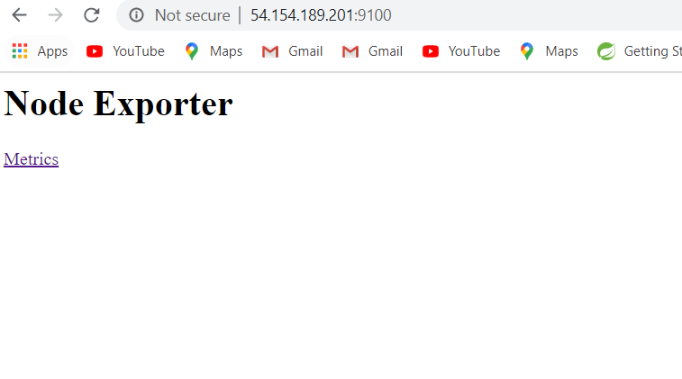

Figure 131 the image above shows node exporter working on my ec2 instance

The next step was to connect node exporter to Prometheus so that the metrics that I needed can be gathered in. The screenshot below shows the modifications that I performed on the promethesis.yml file.

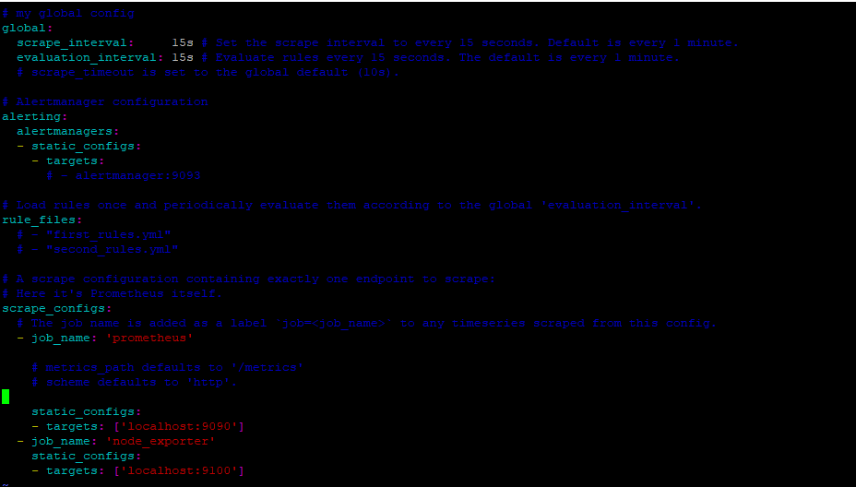

Figure 132 modified Prometheus.yml file

To confirm that you have connected node exporter to Prometheus you can view Prometheus’s target section and view the node exporter endpoint. The image beow shows that they have been successfully connected.

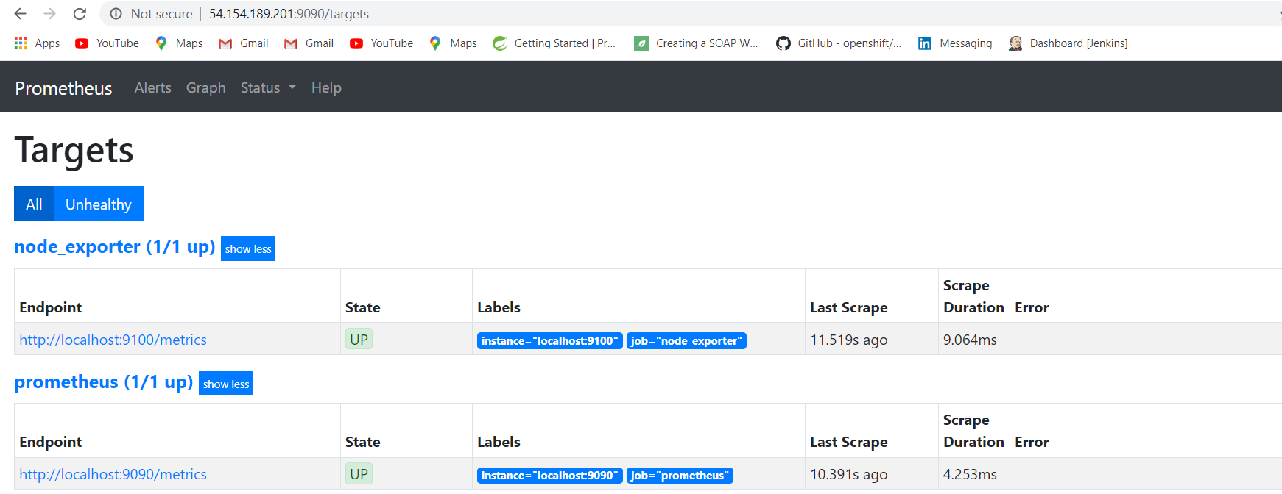

Figure 133 prometheus target section

## 5.4 Grafana

The next tool that was configured is Grafana, which is a visualization tool. The command that was used to this, can be seen in the image below.

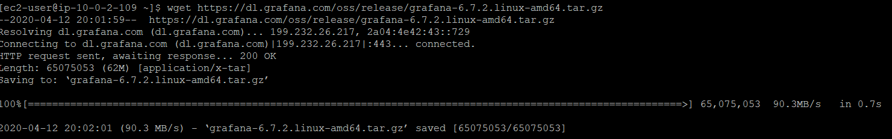

Figure 134 command used to get Grafana packages

After using this command, the next step is to unzip the file. After unzipping the file, the next step was to change the default port that Grafana listens on. The reason for this is simple. The React front end that was designed for the application also listens on this port. So, any attempt to run Grafana on this port will cause a conflict. The image below shows the error that is thrown when Grafana encounters a port conflict.

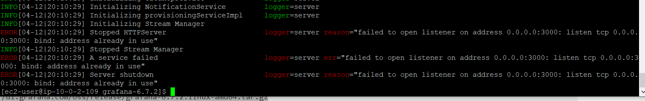

Figure 135 error that is thrown when Grafana has a port conflict

In order to change the default port that Grafana listens on, a change is required to Grafana’s deafault.ini file. The below image shows the change that was made to make Grafana’s default port equal to 912.

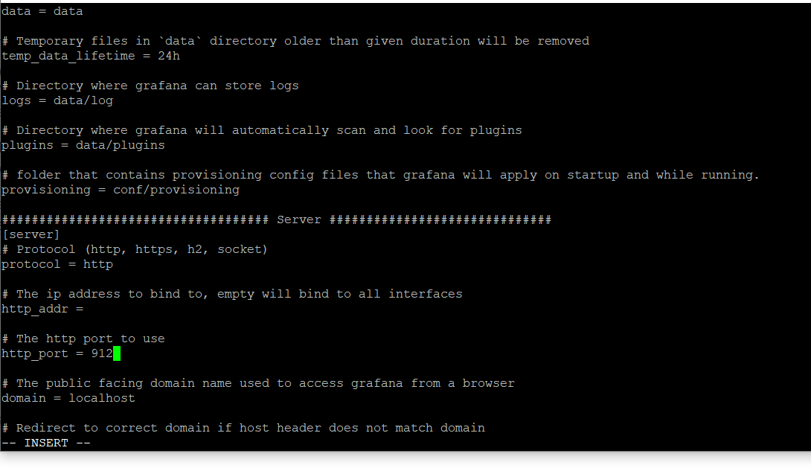

Figure 136 change that was made to default.ini file

After this, the following command can be used to run Grafana ./Grafana. The image below shows the logs that Grafana is generating when started.

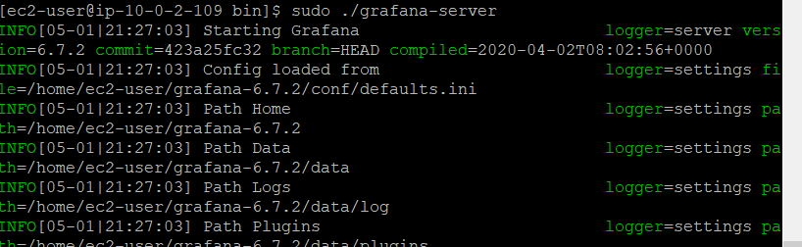

Figure 137 logs after starting grafana

After starting Grafana I can now access via the public ip address.

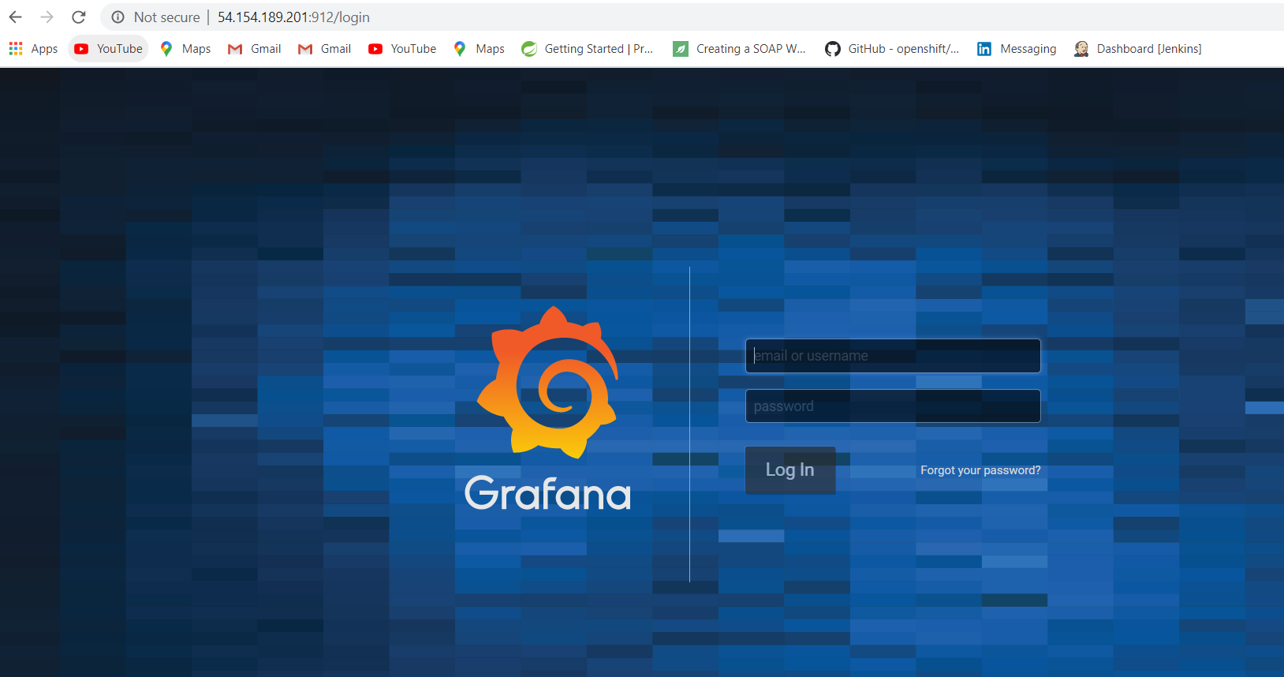

Figure 138 image of Grafana working on production server

The next step that I did was add Prometheus as a data source. This can be seen in the image below.

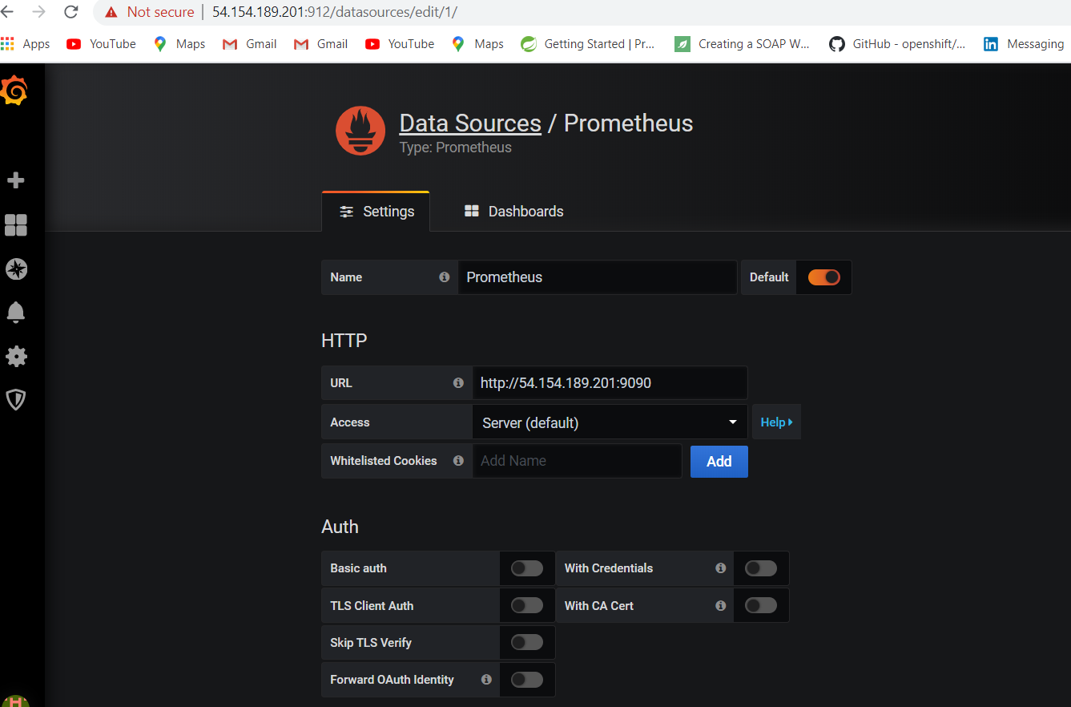

Figure 139 Connecting Prometheus datasource

Following this step, I imported two dashboards for node_exporter so that I could then use Grafana to display the metrics. How I did this can be seen in the images below.

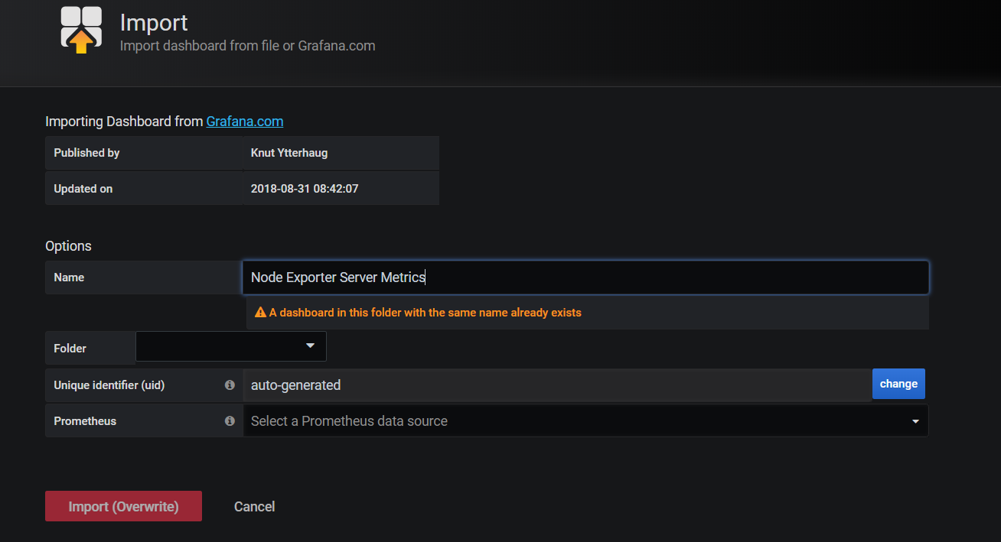

Figure 140 Congiguring node exporter Server metrics

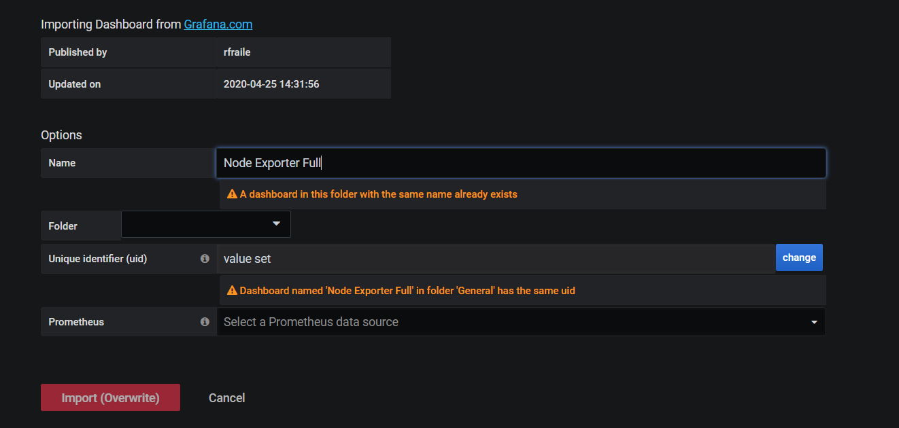

Figure 141 gathering additional server metrics

After configuring these dashboards Grafana is now able to visualize the data this can be seen in the images below.

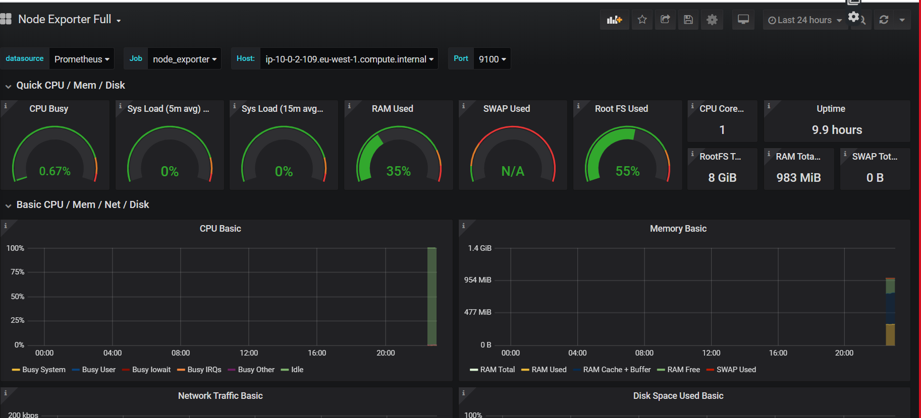

Figure 142 Dashboard 1 metrics

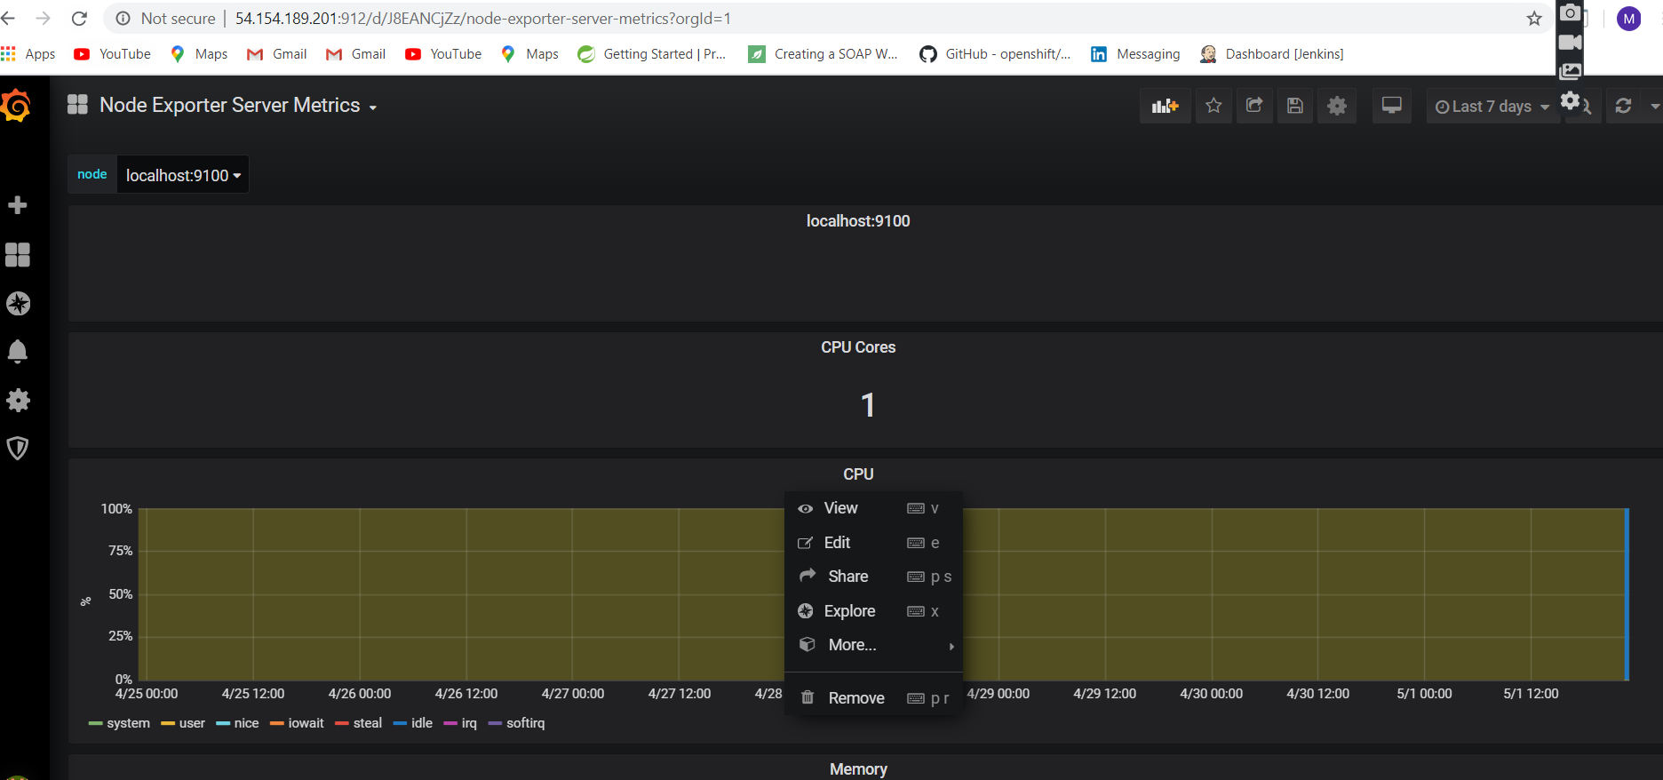

Figure 143 Dashboard 2 metrics

I would just like to highlight that this process is fully automated by my ansible playbook file. Evidence of this can be seen in the video that I submitted.

# Conclusion

Coming from a background that focuses primarily on development, I never really appreciated the level of complexity that was required to facilitate and orchestrate a CI-CD environment. That is something that I have grown to appreciate over the course of this project. From the start my goal was to full automate this process and this is something that I have accomplished as demonstrated above. From my experience Jenkins was a wonderful tool to use the aspect I most enjoyed, is that it can be as simple or as complex as you want to make it. Out of the box Jenkins comes with nothing and can be customized to provide whatever environment the engineer working on it wants to create. This is something that appealed to me greatly and I feel that I have demonstrated an acceptable knowledge of how this tool works.

I also enjoyed the continuous deployment aspect of the project that fact that I was able to commit a code change to git and have it live on my production environment when my pipeline finished executing really fascinated me.

Ensuring that poor quality code was not allowed into my production environment was another very interesting aspect. Using SonarCloud to ensure that code had to be of a certain quality before it was deployed was something that appealed to me. I can see the industry use for this as you can impose a company’s policy of code quality on the development team. This would ensure that applications produced by them are of a certain quality which benefits everyone. The developers learn to code to a higher standard and the company produces applications that they can trust

Finally, I was really impressed with how powerful ansible software is. I had never interacted with this software before. So, I had no clue as to how much how much ansible could do. I imagine if you really wanted to you could actually remove Jenkins altogether and have ansible provide the CI through use of multiple playbooks. While this would not be the advised course of action, I just wanted to highlight the power of the tool. Overall, I really enjoyed my time working on the project and I feel like I have filled some gaps in my knowledge as I prepare to face the industry in the summer.

# References

JenkinsOfficalDocumentation, 2020. *jenkins.* [Online]   
Available at: https://www.jenkins.io/doc/book/pipeline/  
[Accessed 4 April 2020].